NEW EMPLOYEE HANDBOOK

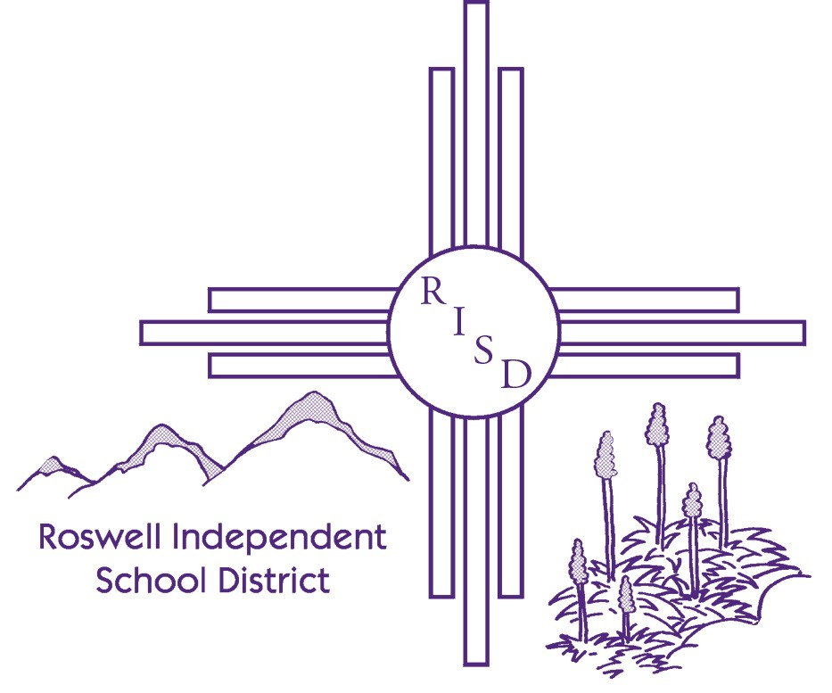
2021-2022

The Roswell Independent School district does not discriminate on the basis of race, color, national origin, sex, disability, or age in its educational programs, services, or activities and provides equal access to the Boy Scouts and other designated youth groups. These same non-discrimination safeguards apply to all hiring and employment practices.

El distrito escolar independiente de Roswell no discrimina en función de la raza, el color, el origen nacional, el sexo, la discapacidad o la edad en sus programas, servicios o actividades educativas y brinda igualdad de acceso a los Boy Scouts y otros grupos juveniles designados. Estas mismas garantías de no discriminación se aplican a todas las prácticas de contratación y empleo.

TABLE OF CONTENTS

- MISSION & VISION 4
- EMPLOYEE GROUP REPRESENTATIVES 5
- PRINCIPALS & SUPPORT STAFF PHONE NUMBERS 6
- INSURANCE INFORMATION 7
- ABSENCE MANAGEMENT 8
6. DOSSIER INFORMATION 10
7. RISD WEBSITE INFORMATION 13
8. BOARD POLICIES
- CODE OF ETHICS OF RISD 14
- CODE OF CONDUCT 17
- ACCEPTABLE TECHNOLOGY USE 21
- SEXUAL HARASSMENT 25
- SEXUAL HARASSMENT OF STUDENTS 27
- REPORTING VIOLATIONS OF LAW 30
- TOBACCO-FREE SCHOOLS 31
- DRUG-FREE SCHOOLS, CAMPUSES, AND WORKPLACE 32
- QUALIFICATIONS FOR TEACHERS 34
- APPLICANTS FOR INSTRUCTIONAL POSITIONS: EXPERIENCE 36
- POLICY PROHIBITING PHYSICAL MISTREATMENT OF STUDENTS 37
- POLICY PROHIBITING CORPORAL PUNISHMENT OF STUDENTS 38
- REPORTING CHILD ABUSE AND NEGLECT 39
- TITLE IX & SECTION 504 – NON DISCRIMINATION POLICY 40
- POLICY ACKNOWLEDGEMENT FORM……………………………………….. 44
ROSWELL INDEPENDENT
SCHOOL DISTRICT
2021-2022

Mission Statement
RISD will inspire, empower, and educate each student to become a successful, responsible citizen while celebrating diversity through valued partnerships with families, students, staff and community.

Vision Statement
Excellence in Education. Success in Society

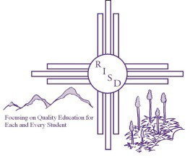

EMPLOYEE GROUP
REPRESENTATIVES

Certified Personnel Unit Representatives
Denise Dawson Rhonda Robinson Kathy Barltett 575-317-9289 575-637-2842 575-637-3574

Associate & Secretarial Unit Representatives
Denise Dawson 575-317-9289

Custodial & Maintenance & Security Guard Unit Representatives
Jerryme Ledesma Raul Castro Albert Cruz 575-308-8172 624-0363/637-3200 575-627-2800

Administrative Representatives
Chad Cole Mireya Trujillo
627-2537 627-2519

SCHOOL INFORMATION

School | Address | Phone Ext.
Goddard High | 701 E. Country Club | 575-627-4800
Roswell High | 500 W. Hobbs | 575-637-3200
University High | 25 W. Martin Rd. | 575-627-2750
Early College High | 25 W. Martin Rd. | 575-624-7020
Berrendo Middle | 800 Marion Richards Rd. | 575-627-2775
Mesa Middle | 1601 E. Bland | 575-627-2800
Mt. View Middle | 312 E. Mt. View Rd. | 575-627-2825
Sierra Middle | 645 S. Sycamore | 575-627-2850
Berrendo Elementary | 505 W. Pine Lodge | 575-627-2875
Del Norte Elementary | 2701 N. Garden | 575-637-3325
East Grand Plains Elementary | 3773 East Grand Plains | 575-637-3350
El Capitan Elementary | 2807 W. Bland | 575-637-3401
Military Heights Elementary | 1900 N. Michigan | 575-637-3425
Missouri Avenue Elementary | 700 S. Missouri | 575-637-3452
Monterrey Elementary | 910 W. Gayle | 575-637-3475
Nancy Lopez Elementary | 1208 E. Bland | 575-637-3500
Parkview Early Literacy | 1700 W. Alameda | 575-637-3525
Pecos Elementary | 600 E. Hobbs | 575-637-3550
Sunset Elementary | 606 W. O’Conner Rd. | 575-637-3575
Valley View Elementary | 1400 S Washington | 575-637-3600
Washington Avenue Elementary | 408 N. Washington | 575-637-3625

INSURANCE INFORMATION

New Mexico Public Schools Insurance Authority.
(https://nmpsia.com/main.html) . . . . . .1-800-233-3164
Dental
- United Concordia (www.unitedconcordia.com) 1-888-898-0370
Prescription Drugs

❑ Express Scripts (www.) ...................................................................................... 1-800-498-4904
Medical

❑ Blue Cross Blue Shield of NM (www.bcbsnm.com)1 ...........................................1-888-966-7742
❑ Blue Cross Blue Shield Preferred EPO…………………………………………………………1-888-966-7742
❑ Presbyterian (www.phs.org)..............................................................................................1-888-275-7737
Vision

❑ Davis Vision (www.davisvision.com).............................................................................1-800-999-5431
Long-Term Disability

❑ The Standard (www.standard.com) ..............................................................................1-800-842-1718
Pension System Administrators

- New Mexico Retiree Health Care Authority (www.nmrhca.state.nm.us)
1-800-233-2576
- New Mexico Education Retirement Board (http://www.nmerb.org)
1-505-827-8030
Life Insurance
- The Standard Life Claims (www.standard.com) 1-800-524-0542

If the numbers listed above fail to resolve your question, call the Human Resource Office at 575-627-2523.

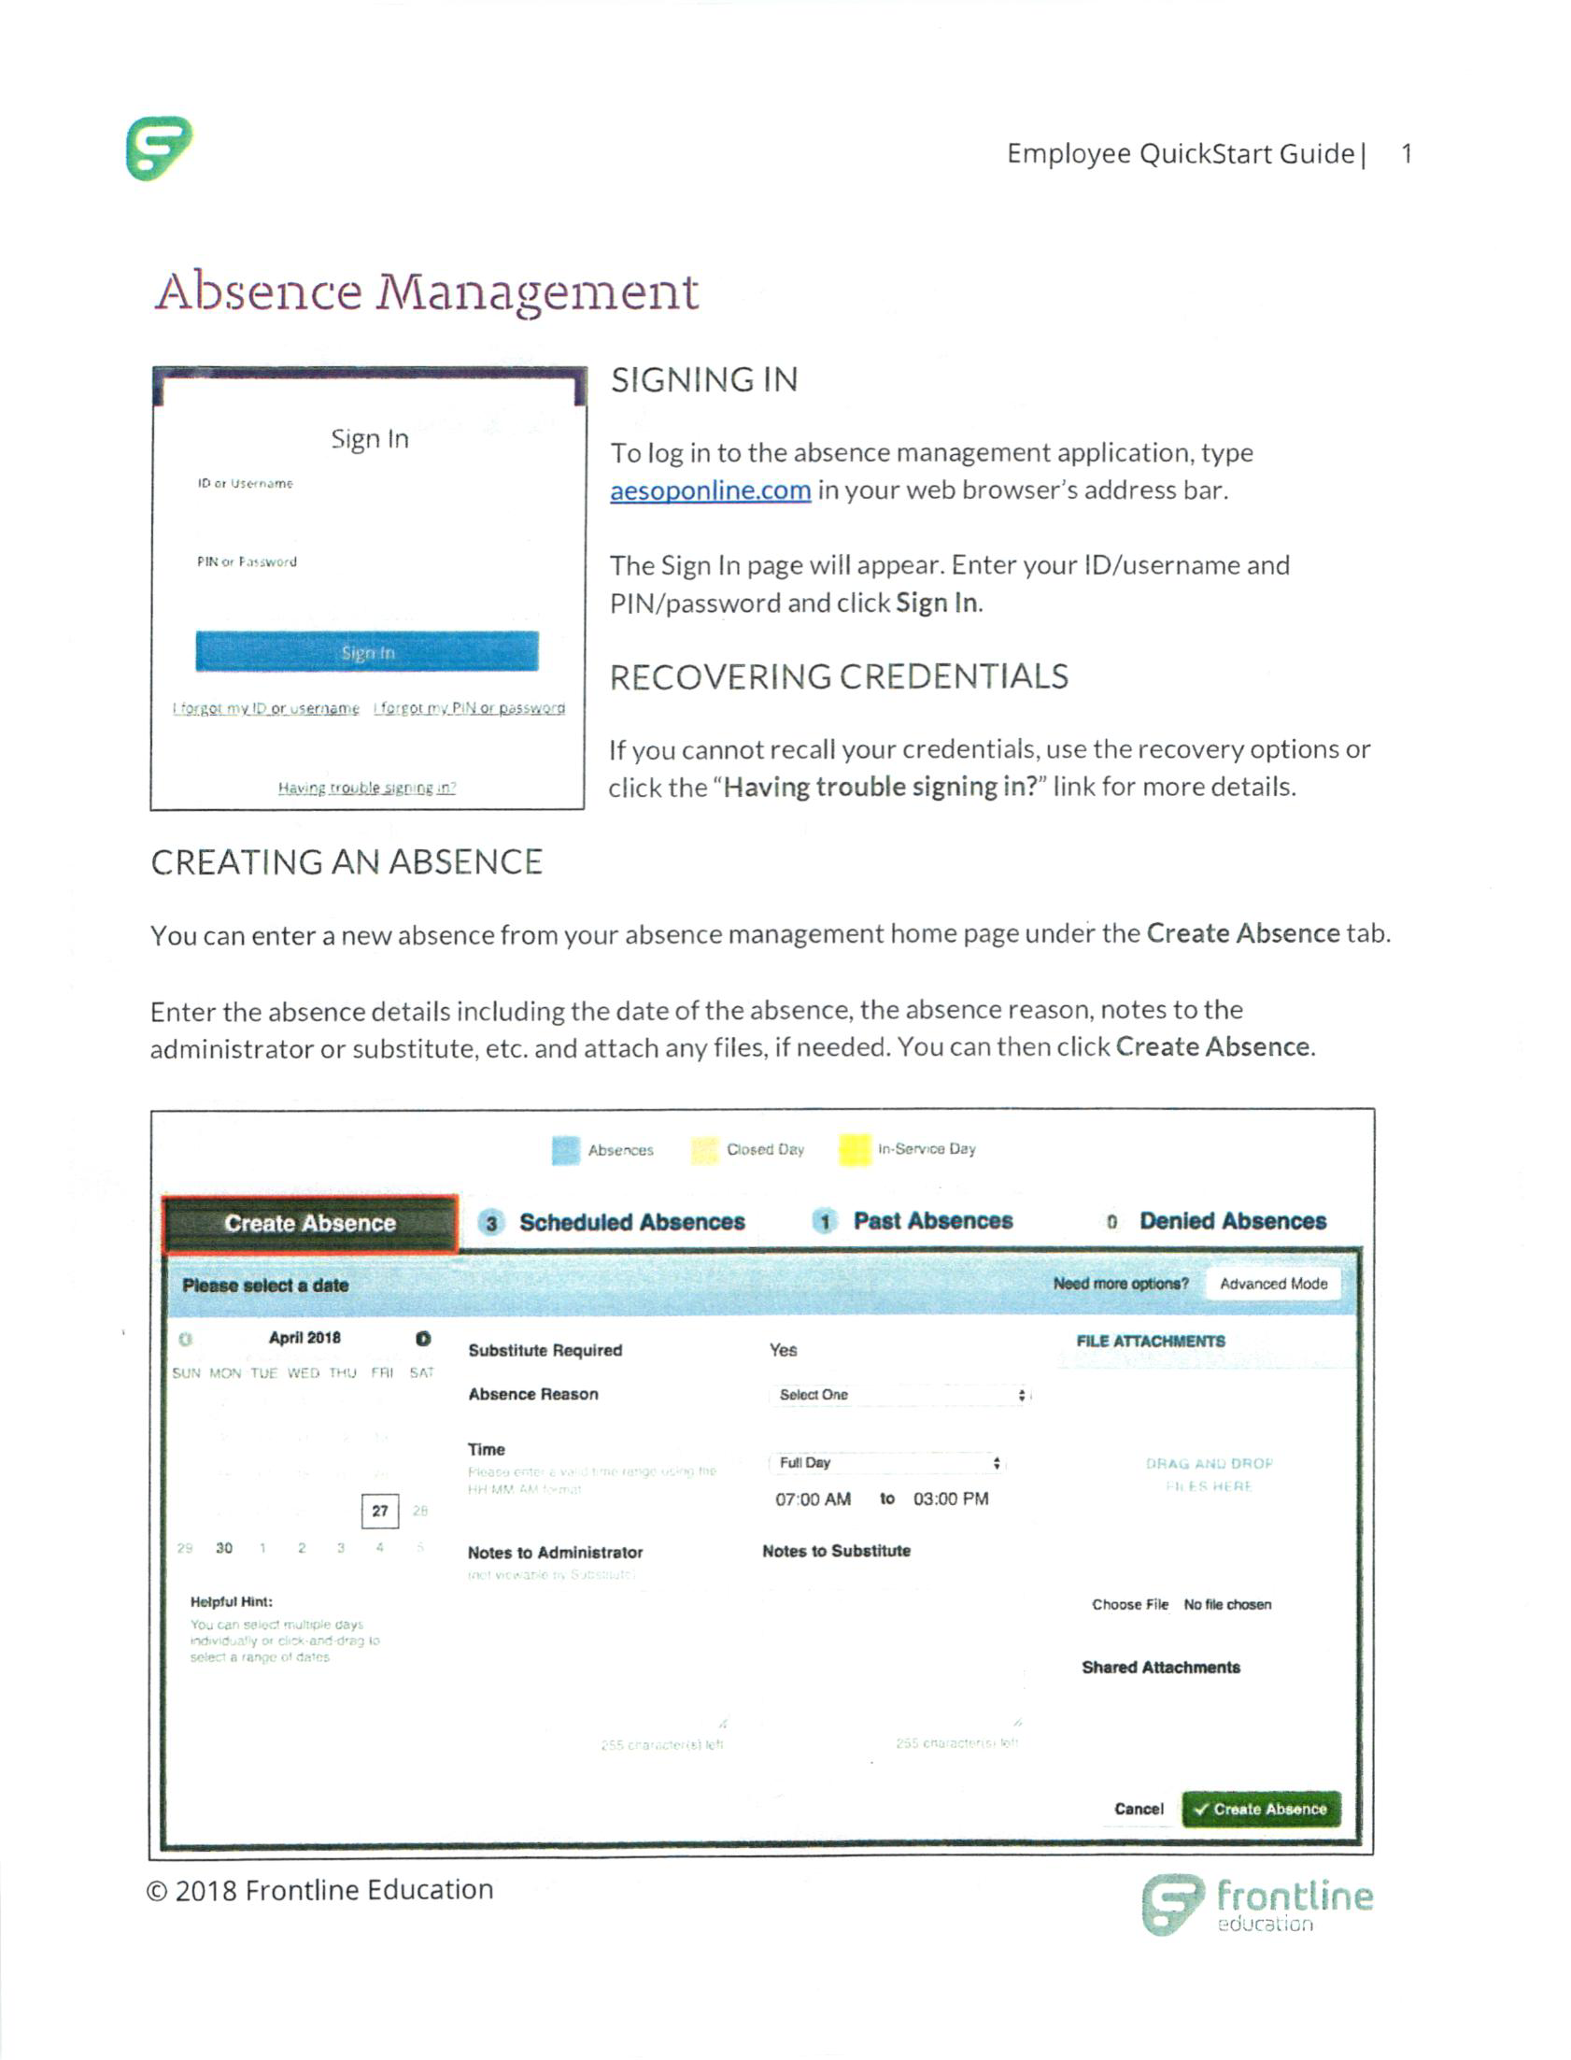

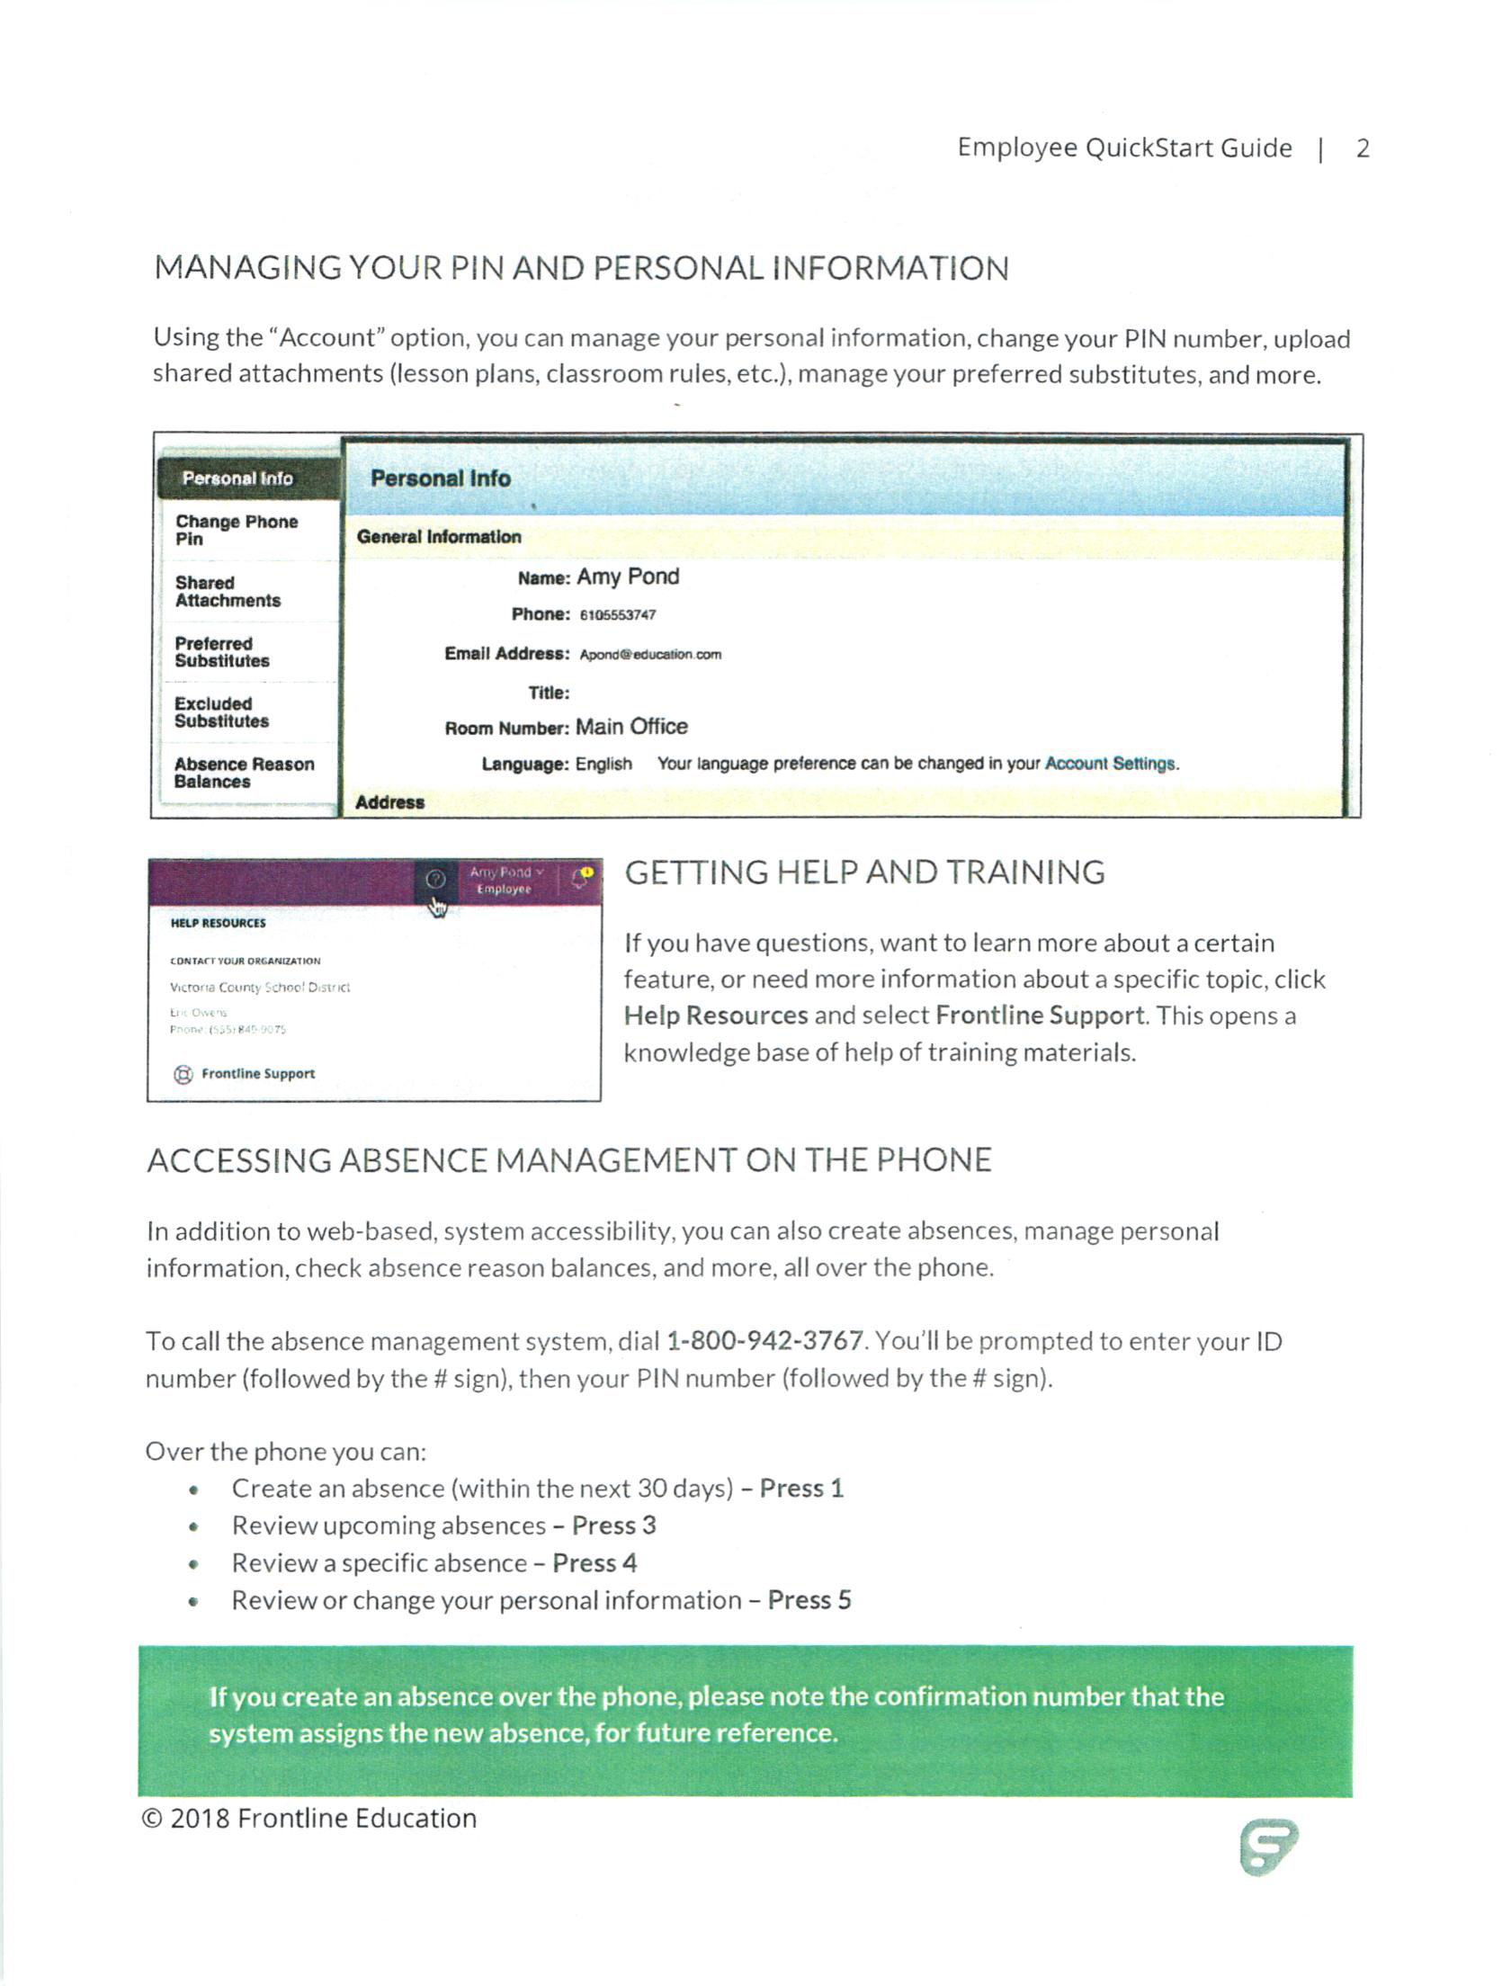

DOSSIER INFORMATION

When do I have to do my dossier?
Level I licensed teachers have up to five years to complete the required dossier to advance
to Level II. We strongly encourage Level I teachers to complete the required dossier at the
end of the third year to move to Level II and attain the $40,000 minimum salary level in the
timeliest manner possible. Level II licensed teachers may choose to advance to Level III. In
order to do so, they must first have at least three years of experience at Level II and a master's
degree or National Board Certification. They must successfully complete the dossier unless
they have already completed the assessment afforded through National Board Certification.
National Board Certified teachers do not have to complete Strands A, B, C and D of the dossier
since these requirements are met through the National Board Portfolio, but must obtain the
superintendent's recommendation for advancement included in Strand E.

When is my dossier due?
The dossier submission date begins on July 15th and closes March 31st of the following year.

Who will I submit it to?
Dossiers will be submitted by fax or online to the approved state contractor. Look for information at http://www.teachnm.org.

What kind of help will be available to me?
Districts have a number of sources for helping teachers preparing their dossiers. In some locations the school district has trainers available. Other professional development providers include the RECs for rural districts, RETA-NM for online training facilitated at local sites, as well as other organizations. Look for information about ongoing training opportunities at www.teachnm.org.

How will it be evaluated?
Dossiers will be evaluated by two external reviewers. One reviewer will be from the same content area and/or school level (elementary, etc.) as the advancement applicant. External reviewers will have extensive training for dossier assessment. The Requirements & Guidelines for the Preparation of the Professional Development Dossier includes more detailed information about the evaluation process.
The PDD Criteria for Success will serve to guide the work of the external reviewers during the evaluation process.

When will I find out the results?
Within one-two months after submission of the dossier.

How long can my scores be banked?
If a candidate for advancement to Level III does not meet on or more strands, he/she may retain the strands rated “Meets” for two calendar years. Level II candidates may retain strands rated “Meets” up to fifth year allowed at Level I. Resubmission only has to address the strands rated “Not Meets” in order to determine a final “Meets” score for all strands.

Can I use the same work in Strand A and Strand B?
Strand A and Strand B have two different purposes. In Strand A, the teacher demonstrates that he/she can plan effectively for instruction and assess the results. Through an explanation supported by evidence of what occurs in a 3-5 hour segment of instruction, the teacher describes how activities and assessments fit the needs and learning goals of students in his/her classroom. As part of the evidence, the teacher provides one high, mid-range and low-achieving student work example related to this segment of instruction (3 student work examples altogether). In Strand B, the focus is on student learning. The teacher demonstrates how he/she supports student learning over an extended period of time – from a week up to one semester. The teacher collects 3-5 examples of each of two student’s work that illustrates learning over an extended period of time. The students chosen for Strand B should be different from the students whose work you use in Strand A. They may be from the same class you used for Strand A or they may

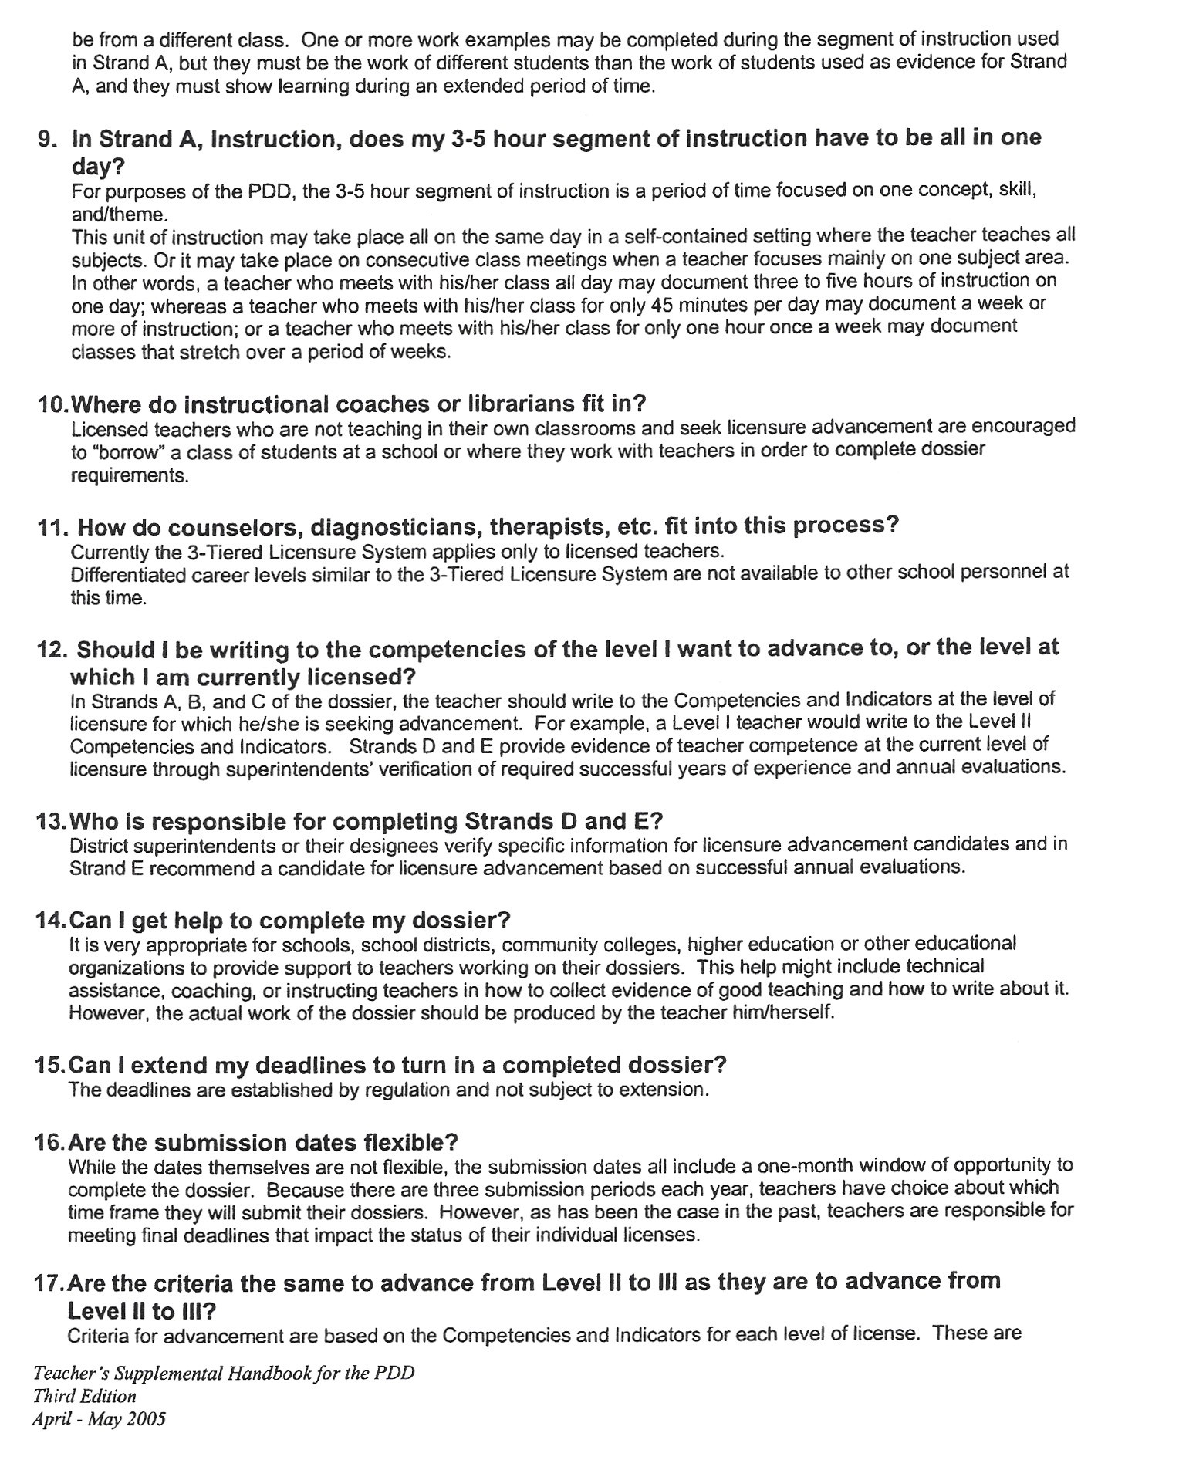

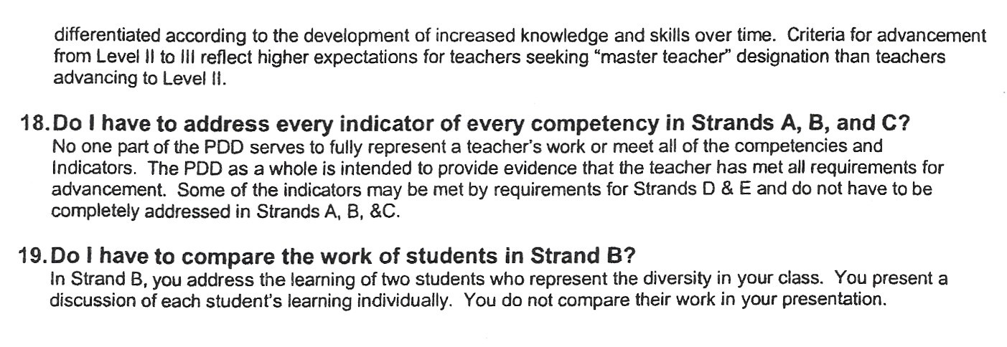

RISD WEBSITE

Where to find information on the RISD website.

WWW.RISD.K12.NM.US

RISD CALENDAR HOME PAGE

BOARD POLICIES HOME PAGE

PAY SCHEDULE
WORK AGREEMENT TIMESHEETS TRAVEL REIMBURSEMENT

BUSINESS OFFICE PAGE

SICK BANK
SALARY SCHEDULES VACANCIES EMPLOYEE CALENDARS INSURANCE INFO FMLA FORMS

HUMAN RESOURCES PAGE

ATHLETIC INFO ATHLETICS PAGE

GBEA CODE OF ETHICS OF ROSWELL INDEPENDENT SCHOOL DISTRICT

I.
ADOPTION OF STATE CODE OF ETHICS: LICENSED PERSONNEL

The Board of Education recognizes that the State Board of Education has set standards of acceptable ethical behavior and professional conduct in education that are applicable to all licensed school personnel, instructional personnel under contract, including any other person who provides instructional services in a school but who does not hold a standard license and whose presence is authorized by the SBE through a waiver, substandard license, or an educational plan approved by the SBE. See Code of Ethical Responsibility of the Education Profession, NMAC 6.60.9.1 to 6.60.9.12.

The Board of Education further recognizes the need to adopt local standards of ethical behavior which, if violated may constitute just cause for termination or discharge of licensed personnel.

As a result, the Board of Education hereby adopts the State Board's Code of Ethics, NMAC 6.60.9.9 and by such adoption, makes the code of ethics therein applicable to all licensed personnel of the School District and compliance with those ethical standards a contractual duty of all licensed personnel of the District.

PREAMBLE

We, professional educators of the Roswell Independent School District, affirm our belief in the worth and dignity of humanity. We recognize the supreme importance of the pursuit of truth, the encouragement of scholarship, and the promotion of democratic citizenship. We regard as essential to these goals the protection of freedom to learn and to teach with the guarantee of equal educational opportunity for all. We affirm and accept our responsibility to practice our profession according to the highest ethical standards.

We acknowledge the magnitude of the profession we have chosen, and engage ourselves, individually and collectively, to judge our colleagues and to be judged by them in accordance with the applicable provisions of this code.

PRINCIPLE I - Commitment to the Student

We measure success by the progress of each student toward achievement of his/her maximum potential. We therefore work to stimulate the spirit of inquiry, the acquisition of knowledge and understanding, and the thoughtful formulation of worthy goals. We recognize the importance of cooperative relationships with other community institutions, especially the home.

In fulfilling our obligations to the student, we:

- Deal justly and considerately with each student.
- Encourage the student to study and express varying points of view and respect his/her right to form his/her own judgment.

PRINCIPLE II - Commitment to the Community

We believe that patriotism in its highest form requires dedication to the principles of our democratic heritage. We share with all other citizens the responsibility for the development of sound public policy. As educators, we are particularly accountable for participating in the development of educational programs and policies and for interpreting them to the public.

In fulfilling our obligations to the community, we:

- Share the responsibility for improving the educational opportunities for all.
- Recognize that each educational institution has a person authorized to interpret its official policies.
- Acknowledge the right and responsibility of the public to participate in the formulation of educational policy.

GBEA CODE OF ETHICS OF ROSWELL INDEPENDENT SCHOOL DISTRICT (CONT'D)

- Evaluate through appropriate professional procedures conditions within a district or institution of learning, make known serious deficiencies, and take any action deemed necessary and proper.
- Assume full political and citizenship responsibilities, but refrain from exploiting the institutional privileges of our professional positions to promote political candidates or partisan activities.
- Protect the educational program against undesirable infringement and promote academic freedom.

PRINCIPLE III - Commitment to the Profession

We believe that the quality of the services of the education profession directly influence the future of the nation and its citizens. We, therefore, exert every effort to raise educational standards, to improve our service, to promote a climate in which the exercise of professional judgment is encouraged, to demonstrate integrity in all work-related activities and interactions in the school setting and to achieve conditions which attract person’s worthy of the trust to careers in education. Aware of the value of united effort, we contribute actively to the support, planning, and programs of our professional organizations.

In fulfilling our obligations to the profession, we:

- Recognize that a profession must accept responsibility for the conduct of its members and understand that our own conduct may be regarded as representative of our profession.
- Participate and conduct ourselves in a responsible manner in the development and implementation of policies affecting education.
- Cooperate in the selective recruitment of prospective teachers and in the orientation of student teachers, interns, and those colleagues new to their positions.
- Accord just and equitable treatment to all members of the profession in the exercise of their professional rights and responsibilities and support them when unjustly accused or mistreated.
- Refrain from assigning professional duties to non-professional personnel when such assignment is not in the best interest of the student.
- Refrain from exerting undue influence based on the authority of our positions in the determination of professional decisions by colleagues.
- Keep the trust under which confidential information is exchanged.
- Make appropriate use of time granted for professional purposes.
- Interpret and use the writings of others and the findings of educational research with intellectual honesty.
- Maintain our integrity when dissenting by basing our public criticism of education on valid assumptions as established by careful evaluation of facts.
- Respond accurately to requests for evaluations of colleagues seeking professional positions.
- Provide applicants seeking information about a position with an honest description of the assignment, the conditions of work, and related matters.

PRINCIPLE IV - Commitment to Professional Employment Practices

We regard the employment agreement as a solemn pledge to be executed both in spirit and in fact in a manner consistent with the highest ideals of professional service. Sound professional personnel relationships with governing boards are built upon integrity, dignity, and mutual respect between employees, administrators, and local school boards.

In fulfilling our obligations to professional employment practices, we:

- Apply for or offer a position on the basis of professional and legal qualifications.
- Apply for a specific position only when it is known to be vacant, and refrain from such practices as underbidding or commenting adversely about other candidates.
- Fill no vacancy except where the terms, conditions, and policies are known.
- Adhere to, and respect, the conditions of a contract or to the terms of an appointment until either has been terminated legally or by mutual consent.
- Give prompt notice of any change in availability of service, in status of applications, or of change in position.
- Conduct professional business through the recognized educational and professional channels.

GBEA CODE OF ETHICS OF ROSWELL INDEPENDENT SCHOOL DISTRICT (CONT'D)

II.
PENALTIES FOR FAILURE TO COMPLY WITH THIS CODE

- The Board of Education finds that adherence to this Code of Ethics has a significant bearing on a school employee's competence, turpitude or the proper performance of his or her duties. Further, the Code of Ethics is intended to provide a valuable framework of personal ethics to assist employees in their interactions with colleagues, students and parents.

- The failure to abide by the standards of ethical behavior set forth in the Code of Ethics may constitute just cause for disciplinary action up to and including termination or discharge of personnel subject to this code, by action of the local school board in accordance with applicable statutory procedures.

- The failure or refusal to abide by the standards of ethical behavior set forth in this code shall constitute insubordination and shall be considered conduct deemed to be outside the normal scope of duties of school personnel and, thus, shall not be subject to the procedures for correction of unsatisfactory work performance applicable to discharge of licensed personnel for unsatisfactory work performance, set forth in NMSA 1978 Section 22-10-21 and 6 NMAC 4.5.1.

- It shall be the duty of the school superintendent to provide written notification to the Director of the Licensure Unit of the State Department of Education, after taking final action to discharge or terminate the employment of any licensed or certified school employee, or any other person providing instructional services in a school who does not hold a standard license but whose presence was authorized by the SBE through a waiver, substandard license, substitute license, or an educational plan approved by the SBE, based in whole or part on a violation of this Code of Ethics or conduct, for possible license suspension or revocation.

GBEA REV11/01

GBEB CODE OF CONDUCT OF THE ROSWELL INDEPENDENT SCHOOL DISTRICT

I.
CODE OF CONDUCT: ALL PERSONNEL

The Board of Education adopts the following code of conduct for all employees establishing standards and expectations for employee behavior which, if violated, may form a basis for discipline, up to and including termination or discharge.

This code highlights employment responsibilities, and sets forth concrete behaviors appropriate for all school personnel. We are committed to this code and understand that it provides minimally accepted standards of conduct for employees of the District.

To satisfy the obligation, all school employees shall:

  - As to students:
    - Serve as a constructive role model for students of the District in accordance with the State Board's Code of Ethical Responsibility, this policy and local community standards.
    - In compliance with the Family Educational Rights and Privacy Act of 1974 (FERPA) (20 U.S.C. Section 1232g, 29 C.F.R. Part 99 Subparts A-E), the Individuals with Disabilities Education Act (IDEA) (20
U.S.C. § 1401 et seq., 34 C.F.R. Part 300), the Mental Health and Developmental Disabilities Code (43- 1-19, NMSA 1978), the Inspection of Public Records Act (12-2-1A, NMSA 1978), the Public School Code (22-1-8, NMSA 1978), and the Children's Code (32A-2-32, 32A-4-3, NMSA 1978), refrain from disclosing and withhold confidential student records or information about a student or his/her personal and family life unless release of information is allowed, permitted by the student's parent(s)/legal guardian, or required by law.
    - Fraternize with or tutor students outside school or school-sponsored activities only in accordance with local board policies, if any, only after written permission from the student's parent(s)/legal guardian, and only at a place or time approved by the local school and/or the student's parent(s)/legal guardian.
    - Report any instance to the administration in which the employee reasonably suspects that another employee, student or person has engaged inappropriate contact with any student at school or during any school-sponsored activity.
    - Abide by the prohibitions of NMSA 1978 Section 30-9-10 which imposes felony sanctions for a school employee to have sexual relations with a student under 18 years of age.
    - Become familiar with and abide by the School Board's policies related to inappropriate contact with a student or sexual harassment of students by employees or students by students.
    - Report to the administration any instance in which the employee reasonably suspects that a student has been subjected to sexual harassment at school or during school-sponsored activity.

The employee shall avoid or refrain from:

- Using their position as a school employee to exploit or unduly influence a student into engaging in an illegal act, immoral act, or any other behavior that would subject a school employee or student to discipline for misconduct whether or not the student actually engages in the behavior.
- Discriminating, or permit students within the employee's control, supervision or responsibility to discriminate against any other student, on the basis of race, color, national origin, ethnicity, sex, disability, religion, or serious medical condition.
- Giving a gift to any one student unless all students situated similarly receive or are offered gifts of equal value for the same reason.
- Lending a student money except in clear and occasional circumstances, such as instances in which a student may go without food or beverage or be unable to participate in a school activity without such financial assistance, and shall report all such instances and the reason therefore to the employee's supervisor as soon as practicable after the instance.
- Having inappropriate contact with any student, whether or not on school property, which includes, but is not limited to:
  - All forms of sexual touching, sexual relations or romantic relations;
  - Inappropriate touching including but not limited to any physical touching, embracing, petting, hand-holding, or kissing that is unwelcome by the student or is otherwise inappropriate given the age, sex and maturity or the student;
  - Any open displays of affection toward mostly boys or mostly girls;

GBEB CODE OF CONDUCT OF THE ROSWELL INDEPENDENT SCHOOL DISTRICT (CONT'D)

  - Offering or giving a ride to a student unless absolutely unavoidable, such as instances in which a student has missed his/her usual transportation and is unable to make reasonable substitute arrangements, and shall report all such instances and the reason therefore to the employee's supervisor as soon as is practicable after the instance.
- Interfering with a student's right or access to a public education by sexually harassing a student or permitting students within the control, supervision or responsibility of the employee to sexually harass any other student, which includes:
  - Avoid making any sexual advances, requests for sexual favors, repeated sexual references, and avoid any name-calling by means of sexual references or references directed at gender-specific students; avoid any other verbal or physical conduct of a physical nature with a student even where the employee believes the student consents or the student actually initiates the activity, and any display or distribution of sexually-oriented materials, or information where students can see them;
  - Avoid creating an intimidating, hostile or offensive school environment by, at a minimum, not engaging in any of the prohibited behaviors set forth in subparagraphs (8) or 9(a) above.
- Engaging in unauthorized or inappropriate discipline of a student or corporal punishment in excess of, or contrary to, local school board policy, and in exercise of disciplinary action towards students, the employee shall:
  - Control anger, de-escalate conflicts and confrontations, and avoid losing his or her temper, and refrain from any form of excessive physical discipline or physical or verbal abuse of students. Physical intervention shall be used only to restrain student’s actively engaged in or threatening physical violence or harm toward himself, other staff members or students. Instances of such physical restraint shall be reported to the administration as soon as practicable;
  - Refrain from using derogatory terms, offensive names or nicknames, or vulgar or profane language directed to, in the vicinity of, or when referring to students. School personnel shall further avoid name-calling, racial epithets or racially insensitive terms, crude anatomical references, racial, ethnic or sexual jokes or slurs, or offensive or pejorative verbal or non-verbal communication, signs or other physical gestures, which are likely to elicit a negative response. It shall be the duty of the employee to assure that particular forms of communication as specified herein are appropriate for use in a school setting or in the context in which he or she proposes to use them;
  - Avoid being provoked into a response barred by this policy, by student conduct or communication.
- Engaging in violent or threatening behavior toward students, regardless of provocation, except when required for the immediate defense from serious physical harm of the employee, another student, and staff member or authorized person on campus.

  - IN GENERAL, the employee shall:

    - Comply with all school board policies and administrative regulations, and if applicable, approved collective bargaining agreements, setting forth specific employee behavior or conduct standards.
    - Become familiar with and abide by the School Board's policies related to sexual harassment of employees.
    - Report to the administration any instance in which the employee reasonably suspects that a school employee, school visitor, or other person present at school or a school-sponsored activity has been subjected to sexual harassment.
    - Use educational facilities and property only for proper purposes related to legitimate School District business or purposes for which they are intended consistent with applicable policy, law and regulation.
    - Respond in a constructive and professional manner to lawful directives, instructions or requests from supervisors or administrators.

GBEB CODE OF CONDUCT OF ROSWELL INDEPENDENT SCHOOL DISTRICT (CONT'D)

The employee shall avoid or refrain from:

    - Making false or misleading statements or failing to disclose a material fact in any application for employment or licensure.
    - Orally or in writing misrepresenting his or her qualifications for an employment position or promotion.
    - Assisting persons in obtaining educational employment whom he or she knows to be unqualified in respect to their character, education, or employment history.
    - Making a false or misleading statement concerning the qualifications of anyone in or desiring employment within the School District.
    - Permitting or assisting unqualified or unauthorized persons to engage in employment within the School District.
    - Disclosing personal, medical, or other confidential information about other employees to anyone unless disclosure is required or authorized by law.
    - Knowingly making false or derogatory personal comments about an employee, although First Amendment-protected comments on or off campus are not prohibited.
    - Accepting any gratuity, gift, meal, discount, entertainment, hospitality, loan, forbearance, favor, or other item having monetary value whose market value exceeds $100.00, excluding approved educational or employment-related awards, honoraria, plaques, trophies, and prizes.
    - Conduct connected with the performance of official duties that is improper, illegal or gives the appearance of being improper or illegal.
    - Sexually harassing any school employee, any school visitor or anyone else whom he or she might encounter in the course of official duties, which includes:
      - Avoid making any sexual advances, requests for sexual favors, repeated sexual references, and avoid any name-calling by means of sexual references or references directed at gender-specific individuals; avoid any other verbal or physical conduct of a physical nature with any of the above-named individuals even where the employee believes they consent or they actually initiate the activity, and any display or distribution of sexually-oriented materials or information where the above-named individuals can see them;
      - Avoid creating an intimidating, hostile, or offensive work/school environment by at a minimum not engaging in any of the prohibited behaviors set forth at subparagraph 11(a) above.
    - Engaging in inappropriate displays of affection, even with consenting adults, while on school property, during school-sponsored activities or school events off campus.
    - Using public school property to conduct personal business or personal affairs without permission of a supervisor.
    - Discriminating against any school employee, or any other person with whom we have any dealings or contact in the course of our official duties, on the basis of race, color, national origin, ethnicity, sex, disability, religion, or serious medical condition.
    - Engaging in any outside employment:
      - The performance of which conflicts with school employment duties or obligations to students;
      - That uses confidential or privileged information obtained from public school employment as part or all of private employment duties;
      - That impairs the physical ability to perform school employment duties.
      - Where the employee is using his/her access to students, student information, and/or school-based information as basis for selling services, gaining clients, obtaining consulting opportunities or in any way obtaining unjustified personal gain.
      - That charges fees for services that the student is otherwise already entitled to receive from the school district without such additional costs.
    - With the intent to conceal or confuse a fact, changing or altering any writing or encouraging anyone else to change or alter any document:
      - In connection with official school duties;
- In connection with another person's official school duties;
- In connection with any standardized or non-standardized testing;

GBEB CODE OF CONDUCT OF ROSWELL INDEPENDENT SCHOOL DISTRICT (CONT'D)

- In connection with any school application or disclosure process;
- In connection with any writing submitted to the Department of Education related to initial or continued licensure, including endorsements.
    - With the intent to deceive, engaging in any conduct or making any statement:
      - That would breach the security of any standardized or non-standardized tests;
      - That would ignore portions of or the entirety of any standardized or non-standardized testing instructions;
      - That would assist students in obtaining services or benefits for which they do not qualify or are not entitled.
    - When on school property or off campus while representing the school or attending a school function, engaging in violent, abusive, indecent, profane, boisterous, disruptive, unreasonably loud or otherwise disorderly conduct which tends to disturb the peace or interfere with or obstruct the lawful mission, processes, procedures or functions of the schools or the School District.
    - Engaging in violent or threatening behavior toward co-workers, supervisors, parents, members of the school community or members of the public, or others with whom the employee has contact in connection with his or her job duties.
    - Engaging in any behavior prohibited by the state's criminal code of conduct, which may result in criminal penalties, civil fines or similar sanctions.

II.
PENALTIES FOR FAILURE TO COMPLY WITH THIS CODE

- The Board of Education finds that adherence to this Code of Conduct has a significant bearing on a school employee's competence, turpitude or the proper performance of his or her duties. Further, the Code of Conduct is intended to provide a valuable framework of personal conduct to assist employees in their interactions with colleagues, students and parents. The Code of Conduct establishes minimal standards of accepted conduct with which all employees are expected and required to comply.

- The failure to abide by the standards of conduct set forth in the Code of Conduct may constitute just cause for disciplinary action up to and including termination or discharge of personnel subject to this code, by action of the local school board in accordance with applicable statutory procedures.

- The failure or refusal to abide by the standards of conduct set forth in this code shall constitute insubordination and shall be considered conduct deemed to be outside the normal scope of duties of school personnel and, thus, shall not be subject to the procedures for correction of unsatisfactory work performance applicable to discharge of licensed personnel for unsatisfactory work performance, set forth in NMSA 1978 Section 22-10-21 and 6 NMAC 4.5.1.

- It shall be the duty of the school superintendent to provide written notification to the Director of the Licensure Unit of the State Department of Education, after taking final action to discharge or terminate the employment of any licensed or certified school employee, or any other person providing instructional services in a school who does not hold a standard license but whose presence was authorized by the SBE through a waiver, substandard license, substitute license, or an educational plan approved by the SBE, based in whole or part on a violation of this Code of Conduct, for possible license suspension or revocation.

GBEB REV 5/06

I-6400 © IJNDB ACCEPTABLE TECHNOLOGY USE

Computer and network access, including Internet access, is available to students and staff of the RISD. Please read this document carefully.
Our goal in offering these services to our school community is to promote educational excellence in schools by providing resource sharing, innovation, and communication.

Technology offers the potential of access to such services as:
- Computer-based tools and applications;
- Instructional resources and materials;
- Networked references, research sources, and library catalogs;
- Electronic mail services;
- Global information and news;
- Correspondence with other institutions;
- Online publishing and information sharing;

With access to computers and people all over the world also comes the availability of material that may not be considered to be of educational value in the context of the school setting. However, on a global network it is impossible to control access to all materials, and an industrious user may discover controversial information. The RISD firmly believes that the valuable information and interaction available on this worldwide network far outweigh the possibility that users may procure material inconsistent with the educational goals of the District. The smooth operation of the network relies upon the proper conduct of the end users that must strictly adhere to the following guidelines and conditions of use. These guidelines are provided here so that you are aware of the responsibilities you are about to acquire. In general, this requires efficient, ethical and legal utilization of the computer and network resources.

This Acceptable Use Policy is binding on all users of the RISD School Net site as a matter of law, whether this agreement is signed or not.

Signing this agreement will help each school determine whether students, parents, and staff are familiar with the responsibilities of using technology and help each school grant technology privileges consistent with each individual's understanding of these responsibilities.

The guidelines and conditions outlined in this policy in no way limit the school districts prerogative to manage its technology system in a manner that is not arbitrary and capricious and is consistent with exiting law in order to adequately supervise, protect, and if necessary, discipline its students and staff.

The RISD reserves the right to revise this policy at any time, and all revisions will take effect immediately, upon approval by the RISD administrators.

Acceptable Use Policy
Computer and Network/Internet Guidelines and Conditions of Use

Acceptable Use -The purpose of educational technology in the RISD is to support its educational goals. Your use of technology must be consistent with the educational objectives of the RISD. Use of computer systems and networks imposes certain responsibilities and obligations on users and is subject to RISD policies and local, state, and federal laws. Acceptable use always is ethical, reflects honesty, and shows courtesy in the consumption of shared resources. It demonstrates respect for intellectual property, ownership of information and system security mechanisms.

I-6400 © IJNDB ACCEPTABLE TECHNOLOGY USE (CONT.)

Privileges/Consequences -The use of technology is a privilege, not a right, and inappropriate use may result in restriction of privileges and other disciplinary action. Listed below are examples of user activities that the RISD deems inappropriate and in violation of this policy. The RISD reserves the right to expand this list as necessary. The RISD retains the right to deny, revoke, or suspend specific user privileges or restrict access to technology resources, require payment for any damage, and bring criminal charges if deemed necessary. Any material used, generated or stored by any user is subject to review. The Information Systems Department has been given the responsibility of monitoring all network activities. The RISD reserves the right to examine, restrict, or remove any material (hard drive, floppy, ZIP Drive, Pen/Flash Drive, CD, etc.) that is on or passes through its technology systems. Access to electronic information related to any student or staff member will be governed by the same policies that would apply to that information if it were not in electronic form. Parents, or legal guardians, may request to see the content of any material created or accessed by their child/children, if technically possible.

Examples of user activities that violate this policy:
  - Using the computer or network to violate any local, state or federal law.
  - Commercial advertising or unethical/illegal solicitation.
  - Accessing a file or web site that contains pornographic or obscene pictures, videos, stories, or other material; making copies of such material, or distributing or exposing others to such material.
  - Using copyrighted material without permission.
  - Sending or receiving messages that are obscene, profane, racist, sexist, inflammatory, threatening, slanderous, or have language soliciting sexual conduct or interaction toward others.
  - Creating and or placing a computer virus on the network or any workstation.
  - Sending messages or information with someone else’s name on it or misrepresenting the source of information you enter or send.
  - Harassing others
  - Requesting or distributing addresses, home phone numbers, or other personal information, which could then be used to make inappropriate calls or contacts.
  - The sharing of personal information commonly regarded as confidential in regard to students and staff.
  - Sending chain letters or engaging in "spamming" (sending an annoying or unnecessary message to large numbers of people).
  - Purchasing something, which obligates the RISD to another party.
  - Revealing home addresses, e-mail addresses, or phone numbers of other students or colleagues.
  - Sharing passwords. The only person to ever use a password is the person to whom it belongs.
  - Attempting to access and/or alter information in restricted areas of any network or in any way violate the confidentiality rights of other users on any network.
  - Any messages, files, Web sites, or user activities that contain materials that are in violation of this policy.
  - Any messages, files, Web sites or user activities that solicit personal information about you or someone else, or request a personal contact with you or another user. (Asks for your address, phone number, credit card number, Social Security number, or to meet you.)
  - Attempts by any user to abuse or damage the system or violate the security of the network and its resources.
  - Any illegal activity or violation of school policy.
  - Political Lobbying
  - Video Gaming (gambling, etc.)
  - Fund Raisers
  - Chat Rooms
  - Instant Messaging Sites
  - Streaming Audio (listening to the radio over the network)
  - Streaming Video (watching movies, etc. over the network)

I-6400 © IJNDB ACCEPTABLE TECHNOLOGY USE (CONT.)

  - Do not allow ANY non RISD employee to “work on”, “fix”, use or download unauthorized programs or features on School District computers (Desktop or Laptop)
  - Using RISD computer equipment for business use (personal or commercial)
  - Failing to report any of these violations to either the Director for Information Systems or your building technology person.

The listing of the above user activities that violate this policy is for illustration only and is not intended to be exhaustive or all inclusive.

Security – Security on any computer system is a high priority, especially when the system involves many users. If you feel you have identified a security problem on the network, you must notify Director for Information Systems Office or building Technology Resource person. Do not demonstrate the problem to other users. Attempts to log on to any network as a system administrator will result in penalties up to expulsion or termination of employment. Attempts to compromise the security, integrity, the functionality of any RISD technology system, or possession of tools, which are designed to so, while on school property, is a violation of this policy. This includes, but is not limited to, the uploading or creation of computer viruses, deletion or alteration of other user files or applications removing protection from restricted areas, or the unauthorized blocking of access to information, applications, or areas of the network. Any user identified as a security risk or having a history of problems with other computer systems may be subject to severe restriction or cancellation of privileges. It is a violation of this policy to introduce or attach any software or hardware, including encryption software and/or devices, to technology used in the RISD, which is not owned by the RISD or specifically authorized by the Director for Information System’s Office or building Technology Resource person. No modification to any hardware or software owned or managed by RISD may be made without specific authorization by the Director for Information Systems. The RISD reserves the right to examine, restrict, or remove any material that is on or passes through its technology systems. Access to electronic information related to any student or staff member will be governed by the same policies that would apply to that information if it were not in electronic form.

Network Etiquette -The user is expected to abide by the generally accepted rules of network etiquette. Users are expected to be polite and use appropriate language. Swearing and vulgar language are considered inappropriate and are a violation of this agreement. Users need to be certain that they do not reveal home addresses, e-mail addresses, or phone numbers of other students or colleagues. Note that electronic mail (e-mail) is not guaranteed to be private. The RISD scans all email for viruses, ad-ware, spy-ware, spam and content.

Messages relating to, or in support of, illegal activities may be reported to the authorities. Please remember that communications and information belong to other people, and should be treated as private property. Please report computers that seem to have a problem, or that are displaying an error message, to the building Information Systems Tech.

Web Publishing Guidelines: Employees and students, under the direction of a teacher, may publish materials on the Internet that support RISD educational goals and are relevant to school-related activities. In publishing information on the Internet, users must adhere to all previously stated conditions and guidelines as well as the following:

An Internet web page may include pictures of students or items of student work, identified by first name only, if the parent/guardian has indicated his or her permission.

No web page will be linked to the student’s personal web address on another server.

Copyright law and District policy do not allow the re-publishing of text or graphics found on the Internet, on District web sites or file servers without explicit written permission.

The failure of a site to display a copyright notice may not be interpreted as permission to copy the materials. The creator/owner of a web site that improperly or illegally presents copyrighted material may not grant permission for the use of that material. Only the copyright owner may provide the permission.

I-6400 © IJNDB ACCEPTABLE TECHNOLOGY USE (CONT.)

Downloading, printing or uploading of files to laptop or school computers, a floppy disk, or a server at school must be approved by a teacher and must be related to school work.

Warranty -The RISD makes no warranties of any kind, whether expressed or implied, for the service it is providing. The RISD will not be responsible for any damages you suffer. This includes loss of data resulting from delays, non-deliveries, misdirected deliveries, or service interruptions caused by its own negligence or your errors or omissions. Use of any information obtained via the Internet is at your own risk. The RISD specifically denies any responsibility for the accuracy or quality of information obtained through its services.

I have read and understand, and will abide by the above Acceptable Use Policy. I further understand that violation of the regulations above is unethical and may constitute a criminal offense. Should I commit a violation, my access privileges may be revoked and I may be subject to other disciplinary actions prescribed by law or other school policies.

I-6400 © IJNDB ADDED 6/06

A-0300 ACA SEXUAL HARASSMENT
The policy of the Board of Education forbids discrimination against any employee or applicant for employment on the basis of sex. The Board will not tolerate sexual harassment by any of its employees, by non-employee volunteers, or by any other persons who work subject to the control of district authorities, whether in the workplace or in other work-related settings.
- Definitions:
  - Conduct of a Sexual Nature

Conduct of a sexual nature may include, but is not limited to, verbal or physical sexual advances, including subtle pressure for sexual activity; touching, pinching, patting, or brushing against; comments regarding physical or personality characteristics of a sexual nature; sexually oriented "kidding", "teasing", double-entendres, and jokes, and any harassing conduct to which an employee would not be subjected but for such employee's sex.

  - Unwelcome Conduct of a Sexual Nature
    - Verbal or physical conduct of a sexual nature may constitute sexual harassment when the allegedly harassed employee has indicated, by his or her conduct, that it is unwelcome.
    - An employee who has initially welcomed such conduct by active participation must give specific notice to the alleged harasser that such conduct is no longer welcome in order for any such subsequent conduct to be deemed unwelcome.
- Sexual Harassment Prohibited
  - For the purpose of this policy, unwelcome sexual advances or requests for sexual favors, and other unwelcome conduct of a sexual nature constitute prohibited sexual harassment if:
- submission to the conduct is made either an explicit or implicit condition of employment;
- submission to or rejection of the conduct is used as a basis for an employment decision affecting the harassed employee; or
- the conduct substantially interferes with an employee's work performance, or creates an intimidating, hostile, or offensive work environment.
  - Specific Prohibitions:

    - Administrators and Supervisors
      - It is sexual harassment for a manager or supervisor to use his or her authority to solicit sexual favors or attention from subordinates when the subordinate's failure to submit will result in adverse treatment, or when the subordinate's acquiescence will result in preferential treatment.
      - Supervisors who either engage in sexual harassment or tolerate such conduct by other employees shall be subject to sanctions, as described in subsection D.
    - Non-managerial and Non-Supervisory Employees
      - It is sexual harassment for a non-administrative and non-supervisory employee to subject another such employee to any unwelcome conduct of a sexual nature. Employees who engage in such conduct shall be subject to sanctions as described subsection D.

A-0300 ACA SEXUAL HARASSMENT (CONT’D)

- Non-Harassing Conduct: Courteous, mutually respectful, non-coercive interaction between employee, including men and women, that is welcomed by both parties is not prohibited by this policy.

- Reporting, Investigation, and Sanctions:
  - It is the express policy of the Board to encourage victims of sexual harassment to report such claims. This may be done through the employee grievance resolution procedure or by reporting such matters to the Principal, the Superintendent, or the President of the Board.
    - Employees who feel that their superiors are conditioning promotions, increases in wages, continuation of employment, or other terms or conditions of employment upon agreement to unwelcome conduct of a sexual nature, should report these conditions to the appropriate administrator. If the employee's direct manager or supervisor is the offending person, the report shall be made to the next higher level of authority.
    - Employees should also report any unwelcome conduct of a sexual nature by superiors or fellow employees if such conduct interferes with the individual's work performance, or creates a hostile or offensive working environment.
    - Confidentiality will be maintained to the extent possible, consistent with the need to conduct an investigation and take remedial actions, and no reprisals or retaliation will be allowed to occur as a result of the good-faith reporting of charges of sexual harassment.

  - In determining whether alleged conduct constitutes sexual harassment, the totality of the circumstances, the nature of the conduct, and the context in which the alleged conduct occurred will be investigated. The Superintendent or the Board has the responsibility of investigating and resolving complaints of sexual harassment.
  - Any employee found to have engaged in sexual harassment shall be subject to sanctions, including, but not limited to, warning or reprimand, suspension, or termination, subject to applicable procedural requirements.

A-0300 ACA REV 10/01

ACA SEXUAL HARASSMENT OF STUDENTS INTRODUCTORY STATEMENT OF POLICY
The effective education of our students requires a school environment in which students feel safe and secure. Sexual harassment of students, whether by employees or by other students, impairs the proper atmosphere for education, and often creates an inequitable climate for learning.

Sexual harassment, whether verbal or by other conduct, can create stress and distraction, and upsetting feelings of fear, inferiority, or anger, which are detrimental to the education of young people. Toleration of sexual harassment also sends the wrong message regarding appropriate social conduct. Sexual harassment is inappropriate behavior in school because it is inappropriate behavior in society.

It is also illegal. Title IX of the federal Education Amendments of 1972 provides that schools must provide an educational program that offers equal educational benefits for boys and girls. Decisions of the United States Supreme Court and the United States Department of Education make clear that sexual harassment of student by employees or by other students may violate the law.

The Board of Education therefore forbids harassment of any student on the basis of sex. The Board will not tolerate sexual-harassment of students by employees or by other students.

The intend of this policy regarding conduct between employees and students is clear and straightforward: No employee of the school district may engage in any conduct of a sexual nature with any student, regardless of the student’s age, ability to consent, or actual consent.

The intent of this policy regarding conduct among students requires some further discussion. Much of the conduct described in the detailed specification of the policy – including sexually-oriented name-calling, graffiti, teasing, etc. – clearly has no place in school, and would not be welcomed by anyone. Requests for dates or other age- appropriate expressions of interest or affection, however, are not characteristically inappropriate, and can even contribute to the socialization process that is a large part of education. Accordingly, requests for dates and other age-appropriate expressions of interest between students is not sexual harassment unless the student to whom such requests or expressions are directed has indicated that they are unwelcome. When a student has made reasonably clear that he or she does not welcome the requests or attention by the other student, it is sexual harassment for the other student to continue to make such requests or give such attention. In other words, you do have to take “No” for an answer.

DETAILED SPECIFICATIO NOF POLICY

Between an employee and a student, sexual harassment in any conduct of a sexual nature. Between students, sexual harassment is unwelcome conduct of a sexual nature. Specific definitions follow:

Definitions and standards of Conduct

  - Conduct of a Sexual Nature

Conduct of a sexual nature may include, but is not limited to:
    - verbal or physical sexual advances, including subtle pressure for sexual activity;
    - sexually suggestive or sexually-oriented gestures;
    - verbal descriptions of sexual activity or soliciting or encouraging such description from students;
    - repeated or persistent requests for dates, meetings, and other social interactions;
    - initiating or repeating rumors, gossip or speculation or creating or circulating written material about a student’s sexuality, sexual activity, sexual preference or orientation, or gender identity.
    - dating, engaging in a romantic or sexual interaction or relationship of any sexual activity with a student;
    - sexually-oriented touching, pinching, patting, staring, pulling at or attempting to look under clothing, or intentionally brushing against another;

ACA SEXUAL HARASSMENT OF STUDENTS (CONT’D)
    - showing or giving sexual pictures, photographs, illustrations, messages, or notes;
    - using physical proximity or closeness as a physical or sexual advance; comments or name- calling of a sexual nature to or about a student regarding alleged physical or personal characteristics, appearance, clothing, sexual preference or orientation, or gender identity;
    - sexually-oriented kidding, teasing, “double-entendres”, and jokes;
    - use of sexually-oriented or nonverbal signs, sounds, facial expressions or gestures to convey sexual messages;
    - writing graffiti of a sexual nature on school property; and
    - any harassing conduct to which a student is subjected because of or regarding the student’s sex, sexual orientation, or gender identity.

  - Standard of Conduct for Employees No employee may engage in conduct of a sexual nature with a student at any time or under any circumstances, regardless of whether such conduct takes place on school property or in connection with any school-sponsored activity.

  - Standard of Conduct for Students: Unwelcome Conduct of a Sexual Nature

- Verbal or physical conduct of a sexual nature by one student of another may constitute sexual harassment when the allegedly harassed student has indicated, by his or her conduct, that the conduct is unwelcome, or when the conduct, by its nature, is clearly unwelcome or inappropriate.

- A student who has initially welcomed conduct of a sexual nature by active participation must give specific notice to the alleged harasser that such conduct is no longer welcome in order for any such subsequent conduct to be deemed unwelcome.

B Reporting, Investigation, and Sanctions

- Reporting: It is the express policy of the Board to encourage students who feel they have been sexually harassed by a school employee or by another student or students to report such claims.

  - Reporting of Sexual Harassment by a School Employee:

    - Any student who believes he or she has been subjected to any conduct of a sexual nature by a school employee may tell a counselor or principal.

    - If a student who believes he or she has been sexually harassed by a school employee feels uncertain about who to tell, or feels uncomfortable telling any counselor, or principal, the student should tell his or her parent(s) about the problem, and ask for the parent(s) help in reporting the sexual harassment to appropriate school personnel.

    - If a student believes he or she has been sexually harassed by a counselor or a principal, or by any other administrator the student should seek the assistance of his or her parent(s) in reporting such harassment to the superintendent or to a member of the Board.

  - Reporting of Sexual Harassment by a Student or Students:

    - Any student who believes he or she has been sexually harassed by another student or other students, may report tell a teacher, counselor, or principal or assistant principal.

    - If a student who believes he or she has been sexually harassed by another student or students, and who feels uncertain about who to tell, or feels uncomfortable telling any counselor, or principal, the student should tell his or her parent(s) about the problem, and ask for the parent(s) help in reporting the sexual harassment to appropriate school personnel.

ACA SEXUAL HARASSMENT OF STUDENTS (CONT’D)

  - Reporting by Employees Mandatory: Any employee who receives or observes any evidence or information of sexual harassment, or who in any manner is made aware of sexual harassment of a student, whether the report or information is given by a student, a third party or another employee, or who himself or herself observes or learns of instances of sexual harassment must notify his or her immediate supervisor or the Superintendent, regardless of whether the employee considers the matter credible or significant. Failure to report sexual harassment may result in sanctions, including, but not limited to, warning to reprimand, suspension, or termination, subject to any applicable procedural requirements.

- Investigation: All reports of sexual harassment of students will be appropriately and promptly investigated by the Superintendent or his or her designee. In determining whether alleged conduct constitutes sexual harassment, the totality of the circumstances, the nature of the conduct, and the context in which the alleged conduct occurred will be investigated.

- Sanctions:

  - Employees: Any employee found to have engaged in conduct of a sexual nature with a student shall be subject to sanctions, including, but not limited to, warning or reprimand, suspension,
or termination, subject to any applicable procedural requirements.

  - Students: Any student found to have engaged in sexual harassment of a student shall be subject to discipline, including, but not limited to, suspension or expulsion, subject to any applicable procedural requirements.

ACA REV 12/05

GBEB REPORTING VIOLATIONS OF LAW

It is the express policy of the Roswell Board of Education:
- To observe and abide by all federal and state laws to which both are subject;
- That all employees shall observe and abide by all federal and state laws in the discharge of their duties; and
- That apparent violations of law in the District’s operations shall be investigated and corrected when found to exist.

In keeping with the foregoing, employees are responsible for reporting apparent violations of law of which they have knowledge for investigation when such violations are committed in the discharge of duties on behalf of the District according to the following:

- REPORTING APPARENT VIOLATIONS OF LAW
  - Any employee who obtains knowledge of facts that reasonably lead such employee to a good faith belief that any other employee or official of the District is violating any state or federal law in the discharge of his or her duties, shall, within ten (10) working days of learning such facts, report such facts in writing to the Superintendent or designee.
  - In the event that the employee reasonably believes the Superintendent is committing the apparent violation, or that the Superintendent is aware of and complicit in the apparent violation, the employee’s written report shall be submitted to the President of the Board of Education.
  - The confidentiality of reports submitted pursuant to this section shall be maintained, subject to the requirements of investigation.

- INVESTIGATION OF REPORTS
  - Reports submitted by employees pursuant to Section A above shall be promptly investigated by the Superintendent, or his or her designee, or, in cases in which such reports are submitted to the President of the Board, by the Board or its designee.
  - In any investigation conducted under this article, the Superintendent or Board may engage the assistance of District legal counsel or other outside investigators to assist in or conduct such investigations.
  - Investigations of reports submitted by employees pursuant to Section A above shall be conducted as confidentially as possible, consistent with an effective investigation. The confidentiality of such investigatory files shall be maintained.
  - A separate investigatory file shall be maintained for each investigation of reports submitted pursuant to Section A above and interim memoranda, investigatory notes, and documents pertinent to the investigation shall be kept in such file.

- DISPOSITION OF REPORT
  - Within twenty (20) working days of receiving a written report submitted under Section A above, the Superintendent or Board shall issue a written disposition stating the results or status of the investigation of the reported violation. The written disposition shall be kept in the investigatory file together with the materials previously filed.
  - A copy of a written disposition shall be provided to the employee who submitted the initiating report.

- NONRETALIATION
  - No employee who has in good faith submitted a report of an apparent violation pursuant to Section A above shall be subject to retaliation of any kind by another employee or administrator of the District.
  - Any employee who believes he or she is being subjected to retaliation in violation of the terms of this article should make such retaliation the subject of a grievance under the Negotiated Agreement grievance procedure.
  - Anyone who subjects another employee to retaliatory conduct as described in D.1 of this section shall be subject to discipline.
  - Anyone who is found to have submitted a report of an apparent violation of law pursuant to this article in bad faith shall be subject to discipline.

GBEB ADDED 9/03

ADB/ADC TOBACCO-FREE SCHOOLS POLICY

A statement within the Goals and Objectives of Education policy of the Roswell Independent School District directs that we "...assist every student in acquiring good health habits and understanding of the conditions necessary for desirable health environment and maintenance of mental, physical, and emotional well-being."

To carry out this policy, to serve as role models for students, to promote further the health of all students and staff, and to promote cleanliness of all facilities, effective July 1, 1990, employee smoking and use of tobacco products shall be prohibited on school property. This shall include school buildings, grounds, and school owned vehicles. This ban extends to all buildings in which employees attend school-sponsored events and meetings after regular school hours.

Employees working directly with students at athletic events and other such activities are prohibited from using tobacco products. A violation of this policy by any employee of the District will be considered insubordination and subject the employee to disciplinary action, pursuant to existing policies of the District.

Employees are encouraged to participate in smoking cessation programs that are available in the community.

The general public and employees are asked to honor the tobacco-free policy as spectators at outdoor extra- curricular events.

ADB/ADC ADDED 10/91

GBEC DRUG-FREE SCHOOLS AND CAMPUSES AND DRUG-FREE WORKPLACE

The purpose of this policy is to insure a drug-free environment for all employees, to establish a drug awareness program for all school district personnel, and to provide assurances to state and federal government agencies that the school district is complying with the requirements of the Drug-Free Workplace Act of 1988 and the Drug- Free Schools and Communities Act of 1986, as amended in 1989, and all regulations promulgated thereunder.

    - The Roswell Independent School District prohibits the employees of the district from unlawfully manufacturing, distributing, dispensing, possessing, or being under the influence of a controlled substance in the workplace. Employees are, also, prohibited from consuming or being under the influence of alcohol in the workplace. Violation of this prohibition may result in imposing of appropriate personnel action against the employee up to and including termination of employment; and/or requiring the employee to participate satisfactorily in a drug abuse assistance, counseling or rehabilitation program approved for such purposes by a federal, state, local health, law enforcement, and/or other appropriate agency, and/or including referral to law enforcement.

    - "Controlled substance" shall mean any narcotic drug, hallucinogenic drug, amphetamine, barbiturate, or any other controlled substance, as defined in the schedules I through V of Section 202 of the Controlled Substances Act (21 USC 812) and as further defined by regulation 21 CFR 1300.11 through 1300.15.3. "Workplace" is defined as the site for the performance of work done in connection with employment, and shall include any place where work of the school district is performed, including a school building or other premises, any school owned vehicle or any other approved vehicle used to transport students to and from school or school activities, and off school property during any school sponsored or school approved activity, event or function where students are under the supervision of the school district.

    - Any employee who is convicted of a violation of a criminal drug statute shall, within five (5) days of the date of such conviction, notify his/her immediate supervisor in writing of such conviction. Once notified, the supervisor shall immediately notify the superintendent, in writing, of said conviction. The Roswell Independent School District, upon receiving written notice, may within thirty (30) days impose appropriate personnel action against the employee up to and including termination of employment; and/or require the employee to participate satisfactorily in a drug abuse assistance, counseling or rehabilitation program approved for such purposes by a federal, state, local health, law enforcement, or other appropriate agency.

    - Events That Will Initiate A Drug And Alcohol Screen
      - A work related accident
      - If an employee’s actions result in the injury of another employee, the employee causing the injury may be tested
      - When a supervisor has reasonable suspicion to believe an employee is under the influence of a controlled substance or alcohol, or such are in the employee’s possession, the employee shall immediately submit to a drug screening.
        - Reasonable suspicion exists when a supervisor observes specific indicators that in their experience and training tend to indicate that an employee may be under the influence of alcohol or a controlled substance. Acceptable indicators include but are not limited to:
          - odor of alcohol on the breath
          - slurred or incoherent speech
          - staggering walk or other loss of physical coordination
          - bloodshot eyes
The supervisor must notify the Assistant Superintendent of Human Resources or his/her designee, as soon as possible of any specific indicators observed, and obtain approval to test the employee. The supervisor must then follow-up with written documentation supporting the finding that reasonable suspicion existed. This documentation shall be submitted to the Assistant Superintendent of Human Resources within forty-eight (48) hours of the reasonable suspicion.

GBEC DRUG-FREE SCHOOLS AND CAMPUSES AND DRUG-FREE WORKPLACE (CONT’D)

      - Substance screening testing will be arranged by the supervisor upon authorization of the Assistant Superintendent of Human Resources or his/her designee and will be conducted by a contracted collection agency. In the case of a “reasonable suspicion” test, the employee shall be transported by the supervisor or his/her designee to the collection/testing agency.
      - Refusal to undergo a substance screening test will be viewed as an act of insubordination. Insubordinate acts will be cause for disciplinary action including and up to termination.

    - The Drug-Free Zone is within 1000 feet of a public school.

    - A drug awareness program shall be established within the school district to inform all employees about:

      - the dangers of drug abuse in the workplace;
      - the school district's policy of maintaining a drug-free workplace;
      - any available drug counseling, rehabilitation, and assistance program;
      - the penalties that may be imposed upon employees for drug abuse violation or drug conviction.

- Each employee of the school district shall be given a copy of this policy and be notified that compliance with the terms of this policy is mandatory.

- The school district shall make a good faith effort to maintain a drug-free workplace through implementation of this policy.

GBEC REV 2/09

GCFC QUALIFICATIONS FOR TEACHERS

Licensure Requirements:

Any person teaching, supervising an instructional program, providing special instructional services in a public school; and any person providing health care and administering medications or performing procedures in a public school shall hold a valid certificate authorizing the person to perform that function. (NMSA 22-10A-3.!)

A person performing the duties of a licensed school employee who does hold a valid license or certificate or has not submitted a complete application for licensure or certificate within the first three months from beginning employment duties shall not be compensated thereafter for services rendered until he demonstrates that he holds a valid license or certificate. (NMSA 22-10A-3.C)

Each certified school instructor in a public school or state agency and each certified school administrator in a public school shall:

(1) enforce all laws and regulations applicable to his public school and school district or to the educational program of the state agency; (2) if teaching, teach the courses of instruction prescribed; (3) exercise supervision over students on property belonging to the public school or state agency and while the students are under the control of the public school or state agency; and (4) furnish reports as may be required.

Alternative (Internship) Licensure:

- A school instructor issued an alternative license under NMSA 22-10A-8 must successfully complete the alternative licensure requirements for an internship licensure per New Mexico Public Education Department Regulation 6.60.3 within three years from the date the internship license was originally issued to be eligible for renewal of an instructor employment contract with the district.

- In the event the school instructor does not meet the requirements for a Level I license at the end of the alternative (internship) licensure three-year period, the school instructor will forfeit all rights to teacher compensation as per NMSA 22-10A-3. C. The person will be eligible to serve the district as a regular substitute teacher and will be compensated as per the District Substitute Teacher Salary Schedule, provided the teacher submits proof of application and appropriate fees for a New Mexico PED Substitute Teacher License.

Certificate of Waiver:

Certificates of teaching or assignment waivers are one-year waivers and may be renewed only if the holder provides satisfactory evidence of continued progress (completion of required hours or passing score on a required test (s)) toward a level one license. A school instructor with a one-year certificate of waiver or certificate of assignment waiver as per NMSA-22-10A-14 and PED Regulation 6.61.9 must complete all requirements of the certificate within the one-year period to be approved by the district superintendent for renewal of contract. All teachers on a teaching or assignment waiver must remove all deficiencies by June 30, 2006, to be eligible for renewal of contract. A teacher who holds a teaching or assignment waiver shall not be assigned to a school that has not made adequate yearly progress for two consecutive years.

Licensure Advancement:

A person holding a valid Level I license wishing to advance to a Level II license or a person holding a valid Level II license wishing to advance to a Level III must meet the requirements of PED Regulation 6.60.6 Continuing Licensure for Licensed Educators in New Mexico. Verification of licensure advancement must be submitted to the district Human Resources Office before October 1st of each school year. Compensation for licensure advancement approved by the PED Licensure Unit after October 1st of each school year will be effective the first day of the following school year.

GCFC QUALIFICATIONS FOR TEACHERS (CON’T)

Highly Qualified Teacher Federal Requirements:

- Regular education teachers who are new to the profession and hired after the first day of school of the 2002-2003 school year who work in a program supported with Title I funds must be “highly qualified” in the core academic subjects they teach.

- Not later than the end of the 2005-2006 school year, all regular education teachers who work in a program supported with Title I funds must be “highly qualified” in the core academic subjects they teach.

- Special education teachers who are new to the profession and hired after the first day of school of the 2002-2003 school year who work in a program supported with Title I funds must be “highly qualified” to provide special education services and, if they also teach the core academic subjects, must be “highly qualified” in the core academic subjects they teach.

- Not later than the end of the 2005-2006 school year, all special education teachers who work in a program supported with Title I funds must be “highly qualified” to provide special education services and, if they also teach the core academic subjects, must be “highly qualified” in the core academic subjects they teach.

- Special education teachers who are new to the profession and hired after the first day of school of the 2002-2003 school year who work in a program supported with Title I funds must be “highly qualified” to provide special education services and, if they also teach the core academic subjects, must be “highly qualified” in the core academic subjects they teach.

- Not later than the end of the 2005-2006 school year, all special education teachers who work in a program supported with Title I funds must be “highly qualified” to provide special education services and, if they also teach the core academic subjects, must be “highly qualified” in the core academic subjects they teach.

Highly Qualified Educational Assistant Federal and PED Requirements:

- Educational Assistants (EAs) hired on or after January 8, 2002 who are assigned to work in a Title I targeted assistance program or in a Title I school-wide program under the Act, must hold a Level III license. Level III EAs shall be assigned and serve as assistants to school staff duly licensed by the Public Education Department. While there may be brief periods when EAs are alone with an in control of a classroom of students, their primary use shall be to work alongside or under the direct supervision of duly licensed staff. (PED Regulation 6.63.9)

- Educational Assistants (EAs) hired prior to January 8, 2002 who are assigned to work in a Title I targeted assistance program or in a Title I school-wide program under the federal Elementary and Secondary Education Act of 1965 [“Act] (20 U.S.C. 6301 et seq., PL 107-110), must hold a Level III license no later than January 8, 2006. Level III EAs shall be assigned and serve as assistance to school staff duly licensed by the Public Education Department. While there may be brief periods when EAs are alone and in control of a classroom of students, their primary use shall be to work alongside or under the direct supervision of duly licensed staff. (PED Regulation 6.63.9)

GCFC REV 7/05

G-2200 © GCBA APPLICANTS FOR INSTRUCTIONAL POSITIONS: EXPERIENCE CONSIDERED

To the extent possible, the RISD Board recognizes the need to apply consistent rules when considering the experience levels of applicants for instructor positions. However, because those years of experience can come from many different sources with varying qualitative value, and because an instructor may have been away from the classroom for a significant period of time, the Board adopts the following limitations on experience that will be considered in setting any new applicant’s salary schedule, whether the applicant is a first time RISD instructor or a returning instructor:

  - For applicants with a BA + 00, the maximum experience that will be considered is 5 years.

  - For applicants with a BA + 15, the maximum experience that will be considered is 20 years.

  - For applicants with a BA + 45 or greater or a master’s/doctorate degree, the maximum experience that will be considered is 20 years under any circumstances.

These experience allocations are caps and may be reduced where appropriate. If the Board or its designee determines that the applicant’s experience does not directly address or have application to the position sought by the applicant, or if RISD administrative officials, in their sole and sound discretion, determine that there is a reason to diminish the experience credit of a particular applicant because of qualitative or quantitative concerns, an applicant’s experience rating may be reduced below the caps outlined above.

Adopted: date of manual adoption

LEGAL REF.: 22-5-11 NMSA (1978)
22-5-14 NMSA (1978)

G-2200 © GCBA ADDED 10/05

JKA POLICY PROHIBITING PHYSICAL MISTREATMENT OF STUDENTS

Introduction: Part of the educational mission of the schools is to instill in students a sense of respect for themselves and for others. In keeping with that purpose, the Board of Education has determined that there is no place for violence in a learning environment, neither by students nor against students. Accordingly, the Board has determined that it is in the educational interests of the school community that any form of physical mistreatment of students be prohibited.

In carrying out that determination through this policy, the Board has taken account of the circumstances employees may face from time to time that call for extraordinary action. In addition, teachers, counselors, and other education professionals frequently observe the educational value of friendly physical contact to reward or encourage students as appropriate in view of the student's age and sex. It is not the purpose of this policy to prohibit or inhibit the types of appropriate friendly contact between professional staff and a student that frequently takes place as part of the educational process--for example, pats on the back, shoulder, arm, or head. The Board believes professional staff members can readily distinguish between appropriate and inappropriate contact in the exercise of sound professional judgment, as well as pursuant to the terms of this policy. To the extent any uncertainty exists on the part of individual staff members, questions should be directed to the administration for clarification.

Physical Mistreatment Prohibited: The Board of Education forbids physical mistreatment by any employee of any student by any employee upon any student. Employees are prohibited from physically mistreating students themselves and from directing or suggesting physical mistreatment of a student by another student.

Definition of "physical mistreatment": For purposes of this policy, physical mistreatment is defined as any action administered upon or directed to the body, including, but not limited to:
  - Striking, squeezing or pinching any part of the body, or forcefully grabbing the body or clothing of a student, or pushing a student;
  - Requiring a student to assume uncomfortable positions (e.g., hands held overhead);
  - Restraining or restricting physical movement through binding or tying;
  - Enclosing a student in a confining space such as a closet, locker, or similar cubicle;
  - Using exercise as a punishment (e.g., pushups, laps); provided, that reasonable exercise may be used as a disciplinary or motivational measure for students in physical education classes, or for students participating in athletic programs, provided such activity is appropriate to the physical and emotional condition of each student.

Exceptions: The following actions are exceptions to this policy, and will not constitute a violation of the policy:
- An employee may reasonably restrain a student whose conduct is violent or physically disruptive if the student's conduct is directed toward any person, including, but not limited to, any employee, another student, any third person on school premises, or the student himself or herself, or the student's conduct is directed toward school property or the property of another on school premises.
- In any instance in which a student has refused valid directives to proceed to, to leave, or to avoid entering any part of the school premises, and the student's refusal creates a disruption or potential disruption of the operations of the school, it is not a violation of this policy for an employee to exercise a reasonable grasp upon, or restraint of, the student for the purpose of moving or removing the student, or for the purpose of preventing the student from entering the premises.
- It is not a violation of this policy for a teacher or administrator to use reasonable physical work as a punishment, analogous to the concept of "community service," including such tasks as sweeping, cleaning, etc., provided, no student shall be assigned to do any heavy or strenuous labor, nor any work unsuitable to the student's age, gender, and physical or emotional capacity.

Interpretation: In assessing an employee's conduct under this policy, consideration will be given to the totality of the circumstances, including what the employee reasonably perceived, what the employee reasonably intended, and whether the employee's conduct was reasonable under the circumstances and in view of the employee's professional status.

Discipline: An employee who is found to have violated this policy shall be subject to discipline, which may include suspension or discharge for any violation. In addition, instances of physical mistreatment of students by employees will be referred to law enforcement and child protective agencies as required by law.
5135 ADDED 12/02

J-4650 © JKA POLICY PROHIBITING CORPORAL PUNISHMENT OF STUDENTS

Introduction: Part of the educational mission of the schools is to instill in students a sense of respect for themselves and for others. In keeping with that purpose, the Board of Education has determined that there is no place for violence in a learning environment, neither by students nor against students. Accordingly, the Board has determined that it is in the educational best interests of the school community that corporal punishment of students be prohibited.

Corporal Punishment Prohibited: The Board of Education forbids physical mistreatment of any student by any employee, to include the administration of corporal punishment upon any student by any employee.

Definition of "Corporal Punishment": For purposes of this policy, corporal punishment is defined as any form of corporal punishment or any action administered upon or directed to the body of a student, including, but not limited to, spanking or paddling.

Discipline: An employee who is found to have violated this policy shall be subject to discipline, which may include suspension or discharge for any violation. In addition, instances of corporal punishment of students by employees will be referred to law enforcement and child protective agencies as required by law.

J-4650 © JKA ADDED 12/02

JLF REPORTING CHILD ABUSE AND NEGLECT

New Mexico law 32A-4-3 requires that school employees who know or suspect that a child is an abused or a neglected child shall immediately report the matter to:

- a local law enforcement agency;

- the department office (Children, Youth and Families) in the county where the child resides.

The school employee shall also report the matter to the school principal or appropriate school official.

So long as such report is made in good faith, the reporting school employee shall be immune from civil liability or criminal sanctions for their action. Any school employee who permits a member of a law enforcement agency or an employee of the human services department to interview the child with respect to that report without the permission of his parent, legal guardian or custodian is presumed to be acting in good faith and shall be immune from civil and criminal liability that might otherwise be incurred, unless the employee acted in bad faith or with malicious purpose.

All employees have a mandatory, nondiscretionary duty to report known or suspected abuse or neglect of a child.

Except as otherwise provided by district policy or procedure, it is not the duty of the school employee making the report to conduct an investigation to determine whether the child identified has in fact been abused or neglected. The duty of school employees to report suspected child abuse or neglect is set forth in Section 32A-4-3 of New Mexico Statutes Annotated, (1993).

The failure of any school employee to report knowledge or suspicion of child abuse or neglect will be cause for criminal prosecution and may be cause for discipline of the employee.

JLF REV 12/03

AC TITLE IX NON-DISCRIMINATION POLICY AND GRIEVANCE PROCEDURES

Non-Discrimination Policy

The Roswell Independent School District is committed to the philosophy of equal opportunity/equal access in all its employments, educational programs, activities and services. All students shall have the opportunity to participate in and receive benefits from all programs or activities including, but not limited to, course offerings, graduation requirements, athletics, counseling, employment assistance, extra-curricular and other school-related activities. Discrimination in education or employment because of race, color, national origin, ancestry, religion, creed, sex, age, physical or mental handicap, marital or parental status, pregnancy, sexual orientation, or veteran status is prohibited.
Inquiries or complaints regarding discrimination in violation of this policy should be directed to: Title IX Coordinator
Director of Activities
Roswell Independent School District 300 N. Kentucky Avenue
Roswell, NM 88201
(505) 627-2515

The employment procedures of the District will be in compliance with all appropriate State and Federal laws. Inquiries or complaints regarding discrimination other than those in violation of this policy with regards to employment with the District should be directed to:

Asst. Supt. for Human Resources Roswell Independent School District 300 N. Kentucky Avenue
Roswell, NM 88201
(505) 627-2518

Sexual Harassment

The District is committed to a positive and productive working and learning environment free of discrimination. Discrimination adversely affects morale and interferes with employee and student ability to work and learn. The District prohibits sexual harassment of its employees or students, whether committed by a co-worker, supervisor, subordinate, contractor, volunteer or student. Such behavior may constitute a basis for disciplinary action up to and including discharge or expulsion. Whereas sexual harassment substantially compromises the attainment of educational excellence, the District will not tolerate such behavior between members of the same or opposite sex.

The District also prohibits retaliation against

- Any employee or student for having made a report of alleged sexual harassment, and

- Against any employee or student who has testified, assisted or participated in the investigation of a report.

Retaliation is itself a violation of State and Federal regulations prohibiting discrimination and may constitute a basis for disciplinary action up to and including discharge or expulsion.

This policy applies to individuals attending any events on the property of the District, whether or not school- sponsored and to any school-sponsored events regardless of location. Any complaints of sexual harassment should be reported within 180 calendar days of occurrence.

A copy of the District’s Sexual Harassment Policy may be obtained at the school-based principal’s office. Nothing in this policy applying to Title IX and Section 504 is intended to alter the District’ Sexual

AC TITLE IX NON-DISCRIMINATION POLICY AND GRIEVANCE PROCEDURES (CON’T)

Harassment policies as set forth in Policy No. 3145 (employees) and Board of Education Policy No. 5130 (students). Inquiries regarding the Sexual Harassment policy should be directed to:

FOR STUDENTS

Title IX Coordinator Director of Activities
Roswell Independent School District 300 N. Kentucky Avenue
Roswell, NM 88201
(505) 627-2515

FOR EMPLOYEES

Assistant Superintendent for Human Resources Roswell Independent School District
300 N. Kentucky Avenue Roswell, NM 88201
(505) 627-2518

Grievance Procedures

Any student or employee of the District, who believes he or she has been discriminated against, denied a benefit, or excluded from participation in any district education program or activity on the basis of sex in violation of this policy, may file a written complaint with the Title IX Coordinator. The Title IX Coordinator will cause a review of the written complaint to be conducted and a written response mailed to complainant within 30 calendar days of receipt of the complaint. The Title IX Coordinator shall provide a copy of the written complaint and the response to the Superintendent of the District and to each member of the Board of Education.

If the complainant is not satisfied with the response of the Title IX Coordinator, he or she may submit a written appeal within 15 calendar days of receipt of the response to the Title IX Grievance Hearing Committee indicating with particularity the nature of disagreement with the response from the Title IX Coordinator and his or her reasons underlying such disagreement. The Title IX Grievance Hearing Committee shall schedule a hearing within 30 calendar days of receipt of the written appeal to review the facts underlying the disagreement and to allow the complainant to present evidence and witnesses regarding his or her disagreement with the response of the Title IX Coordinator. The Title IX Grievance Hearing Committee shall provide the complainant with a minimum of 10-calendar days’ notice of the hearing date. The Title IX Grievance Hearing Committee shall issue a written decision and mail it to complainant within 15 calendar days of the completion of the hearing. The Title IX Coordinator shall provide a copy of the written decision to each member of the Board of Education and the Superintendent.

If the complainant is not satisfied with the decision of the Title IX Grievance Hearing Committee, he or she may submit a written appeal to the Board of Education within five calendar days of receipt of the committee’s decision indicating with particularity the nature of disagreement with the decision of the Title IX Grievance Hearing Committee and his or her reasons underlying such disagreement. The Board of Education shall consider the appeal at its next regularly scheduled meeting following receipt of the complainant’s appeal. At the Board of Education’s sole discretion, it may hear additional evidence regarding the facts underlying the disagreement and may open or close the meeting to the general public as permitted by the New Mexico Open Meetings Act. The Board of Education shall issue its decision and mail it to complainant within 15 calendar days of its meeting

AC TITLE IX AND NON-DISCRIMINATION POLICY AND GRIEVANCE PROCEDURES (CON’T)

The purpose of the Grievance Procedures is to provide a prompt and equitable means for resolving employee and student issues arising on the basis of Title IX and shall be the exclusive procedures utilized in addressing such issues within the District. The procedures enumerated in Board of Education Policy 5395 shall be available to any student who believes a school instructor, coach, activity sponsor or employee decision or action has adversely affected his or her status, rights, and/or privileges as a student outside those granted under Title IX of the Higher Education Amendments of 1972 (and applicable regulations) of the Rehabilitation Act of 1973.

Steps for Filing a Title IX Grievance

- Obtain a Grievance Form from the Title IX Coordinator, Director of Activities or School-based Principal, or prepare a written complaint/grievance.
- Return or mail the completed form or the written grievance with documentation attached to: Title IX Coordinator
Director of Activities
Roswell Independent School District 300 N. Kentucky Avenue
Roswell, NM 88201
- The complaint process will then follow the specific steps and time lines set forth in the “Grievance Procedures” section of this policy.

Standards of Conduct

Every student and employee of the District may rightfully expect that the faculty, staff, activity sponsors, athletic coaches and administration will maintain an environment in which there is freedom to learn and equity in access to any educational program or activity. As members of the District community, employees and students will be encouraged to develop the capacity for: accepting constructive criticism; an openness to critical judgments; engagement in sustained and independent search for the truth; and the ability to exercise their rights to free speech in a responsible, non-violent manner.

Every employee and student shall respect and obey civil and criminal law, and shall be subject to legal penalties for violation of City, County, State and Federal law. Employee and student conduct at the District must conform to district and school-based rules and regulations.

Equity and Participation

The District is committed to nondiscrimination and to provide an equal opportunity for admission, access and participation in its education programs and activities. Each academic course, education program or activity which is reported for state aid is open fully to enrollment and participation by any person who has been admitted to any school within the District and who meets the prerequisites of the course, educational program or activity.

Procedure for Determining How and Whether New Activity Will Be Added to RISD High School’s Athletic Program

Once a year, the Title IX Coordinator, the Principal of each High School (or middle school, if appropriate) and the Superintendent (the Committee) shall meet and confer regarding whether a new activity shall be added to the District’s Activity Program. The addition of new competitive activities will be considered and evaluated by the Committee using the results of surveys conducted during the school year, interest expressed through school registration or through the activity suggestion box. The determination of whether a new activity shall be added will be made using the following criteria:

AC TITLE IX NON-DISCRIMINATION POLICY AND GRIEVANCE PROCEDURES (CON’T)

  - The extent of the interest among students in the new activity.
  - The abilities of the interested students to compete in the new activity.
  - Whether the New Mexico Activities Association (NMAA) sanctions the activity for completion or whether the activity is being played in competition in the community.
  - The presence or absence of the activity in the feeder programs for the High School.
  - Whether there is the opportunity to compete in the activity in an intramural or club-sports program.
  - The overall benefit to the boys’ or girls’ activity program.

Student interest and abilities shall be assessed by implementing the following directives:

- Every four years, the Administration shall conduct an activity survey of all of the students in the District. The survey shall be in the same form as the survey given during the 2003-2004 school year except the survey shall be amended to reflect the current NMAA-sanctioned activities.
- During registration at the beginning of every school year, the Activity Director shall assess the interests and abilities of students for activities, which are not offered by the school. This shall be accomplished by making a form available at the activity sign up table which allows students to express their interest in an activity not offered and which asks students to state what experience they have playing such activity.
- The Activity Director shall set up a suggestion box that is accessible to students at the Activity Office and in each school within the school district. The suggestions found in the box shall be brought to the annual meeting of the Committee.
- Notice shall be published every year in the Student Handbook that informs students that they may express their interest in activities by leaving suggestions in the designated suggestion boxes or by visiting the activity table during registration. The notice shall also inform students that student interest and abilities will be measured through a survey conducted every four years.

Title IX Coordinator

In order to ensure equity and nondiscrimination under Title IX, the District authorizes the Director of Activities to be the Title IX Coordinator to coordinate the school district’s compliance with the requirements of Title IX. The Title IX Coordinator will be responsible to ensure that this policy is adhered to and that the school district notifies all students, parents and employees that (1) it does not discriminate in its programs and activities; and (2) inquiries concerning the nondiscrimination policies may be referred to the designated employee(s). The Title IX Coordinator will direct the school district’s responsibility to provide continuing training to administrators, instructors, coaches, sponsors and employees regarding the appropriate implementation of its Title IX and policy and procedures, including grievance procedures.

Director of Activities

In order to ensure equity and nondiscrimination under Title IX in activities, the District authorizes the Title IX Coordinator to work with the Director of Activities to ensure compliance with Title IX. The Director of Activities is a student advocate and available to assist all students.

AC ADDED 6/09

Roswell Independent School District Board of Education Policies Notice and Acknowledgement
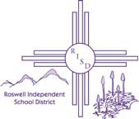

I acknowledge that I have been given a copy of the RISD Human Resources Handbook which includes each of the following RISD Board of Education Policies; I have been given the opportunity to discuss and ask questions and I fully understand that compliance with the terms of each policy is mandatory.

Policy GBEA – Code of Ethics of the Roswell Independent School District Policy GBEB – Code of Conduct of the Roswell Independent School District Policy I-6400 © IJNDB – Acceptable Technology Use
Policy A-0300 ACA – Sexual Harassment
Policy ACA – Sexual Harassment of Students Policy GBEB – Reporting Violations of the Law Policy ADB/ADC – Tobacco Free Schools
Policy GBEC – Drug Free Schools and Campuses and Drug Free Work Place Policy GCFC – Qualifications of Teachers
Policy G-2200 © GCBA – Applicants for Instructional Positions – Experience Considered
Policy JKA – Prohibiting Physical Mistreatment of Students
Policy J-4650 © JKA – Prohibiting Corporal Punishment of Students Policy JLK – Reporting Child Abuse and Neglect
Policy AC – Title IX and Section 504 Non-Discrimination Policy and Grievance Procedures

SIGNATURE
PRINT NAME
WORK LOCATION
SOCIAL SECURITY #
DATE

Roswell Independent School District Board of Education Policies Notice and Acknowledgement

I acknowledge that I have been given a copy of the RISD Human Resources Handbook which includes each of the following RISD Board of Education Policies; I have been given the opportunity to discuss and ask questions and I fully understand that compliance with the terms of each policy is mandatory.

Policy GBEA – Code of Ethics of the Roswell Independent School District Policy GBEB – Code of Conduct of the Roswell Independent School District Policy I-6400 © IJNDB – Acceptable Technology Use
Policy A-0300 ACA – Sexual Harassment
Policy ACA – Sexual Harassment of Students Policy GBEB – Reporting Violations of the Law Policy ADB/ADC – Tobacco Free Schools
Policy GBEC – Drug Free Schools and Campuses and Drug Free Work Place Policy GCFC – Qualifications of Teachers
Policy G-2200 © GCBA – Applicants for Instructional Positions – Experience Considered
Policy JKA – Prohibiting Physical Mistreatment of Students
Policy J-4650 © JKA – Prohibiting Corporal Punishment of Students Policy JLK – Reporting Child Abuse and Neglect
Policy AC – Title IX and Section 504 Non-Discrimination Policy and Grievance Procedures

SIGNATURE
PRINT NAME
WORK LOCATION
SOCIAL SECURITY #
DATE

52

